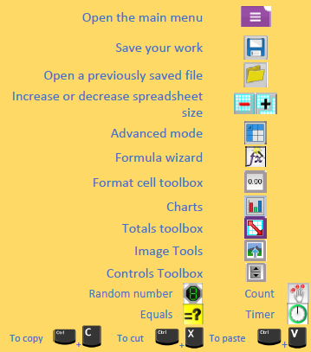

**Key Vocabulary:**

**Average** – Symbols used to represent comparing two values

**Copy and Paste** – A way to copy information from the screen into the computer’s memory and paste it elsewhere without re-typing.

**Columns** – Vertical reference points for the cells in a spreadsheet.

**Cells** – An individual section of a spreadsheet grid. It contains data or calculations.

**Charts** – Use this button to create a variety of graph types for the data in the spreadsheet.

**Equals tool** – tests whether the entered calculation in the cells to the left of the tool has the correct answer in the cell to the right of the tool.

**Formula** – Use the formula wizard or type into the formula bar to create a formula in a cell, this will calculate the value for the cells based upon the value of other cells in the spreadsheet.

**Rows** - Vertical reference points for the cells in a spreadsheet.

**Spreadsheet** - A computer program that represents information in a grid of rows and columns. Any cell in the grid may contain either data or a formula that describes the value to be inserted based on the values in other cells.

**What could we question?**

How would you add a formula so that the cell shows the product of two other cells? Explain what a spreadsheet model of a real-life situation is and what it can be used for?



**Computing Knowledge Organiser**

***Unit of Work:* Spreadsheets**

***Year Group:* 5 *Term:* Summer A**

Key figures: