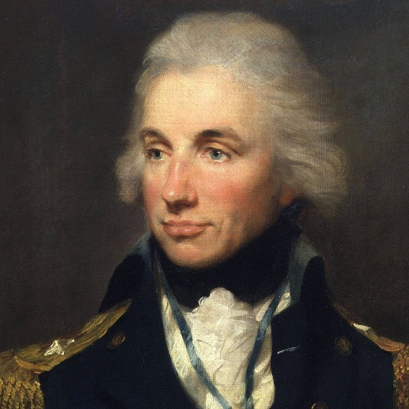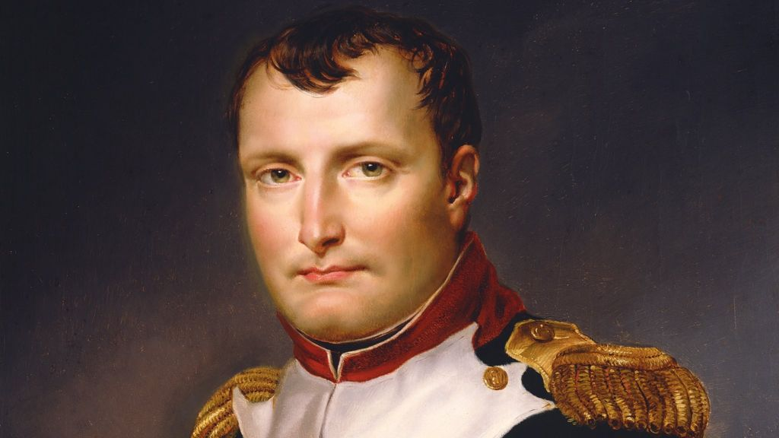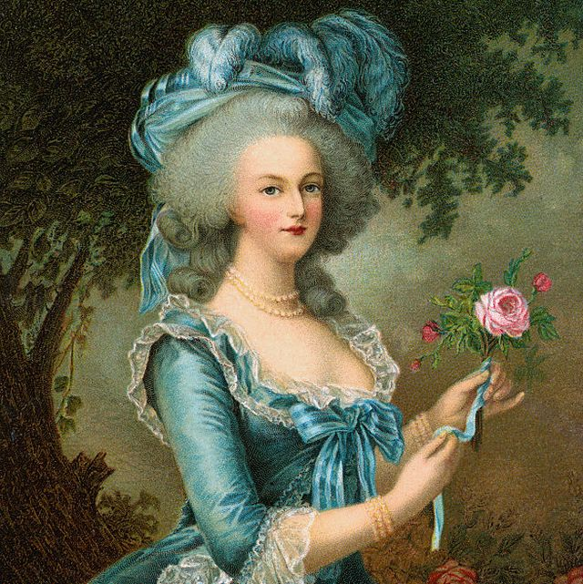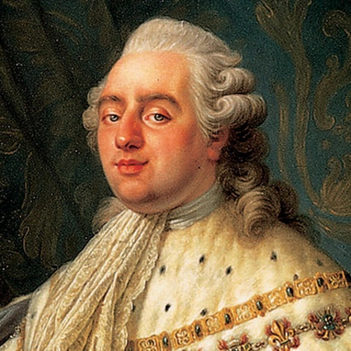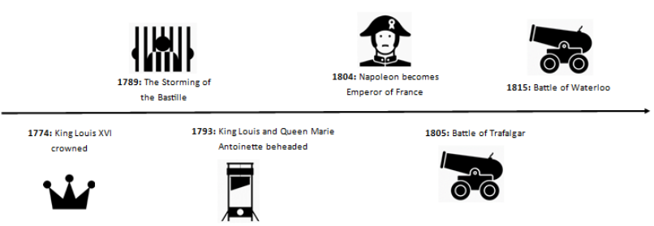

**Key Vocabulary:**

**Revolution** – A time when people overthrow the rulers and try to change how people live and work. **Absolute Monarchy** – When a King or Queen is in complete control and doesn’t need to follow any rules or laws.

**Republic** – A country governed by elected representatives, not by a King or Queen.

**Clergy** – People who have a role within the Church, e.g. Catholic Priest

**Nobles** - Wealthy people from families who are considered important.

**Exile** – When a person is banned from living in a country, often used as a punishment.

**Bastille** – A prison in Paris used by French Kings.

**Key Figures:**

. **King Louis XVI** – Crowned King of France in 1774. Beheaded in 1793.

. **Marie Antoinette** – Became queen of France when her husband became King. Beheaded in 1793.

. **Napoleon** – Hugely successful military leader who became emperor of France. Died in exile on the island of St Helena.

. Horatio Nelson – British admiral in the Royal Navy who defeated Napoleon at the Battle of Trafalgar, preventing an invasion.

. Duke of Wellington – British army general who defeated Napoleon at the Battle of Waterloo.

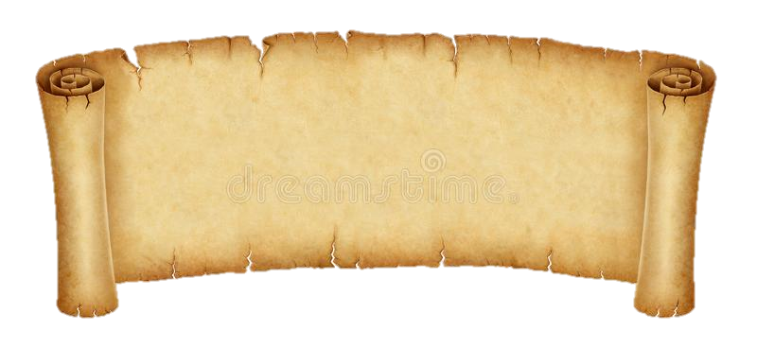

**History Knowledge Organiser**

***Unit of Work:* The French Revolution**

***Year Group:* 5 *Term:* Summer A**

Key figures: