Key Vocabulary: | Definition:
Diverse | Showing a great deal of variety; very different.
Commodity | Something of value that can be bought or sold.
Desertification | A process where productive land, where many things can be grown, is turned into unproductive desert.
Food Security | People living in a country or area have no concerns about food, they have access to it, and they can afford it.
Infestation | Occurs when pests or parasites overrun a location.
Failed Crop | When the crops don’t grow.
Biomes | A large region of Earth that has a certain climate or certain types of living things.
Diverse | Showing a great deal of variety; very different.
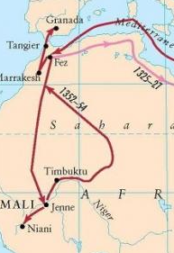
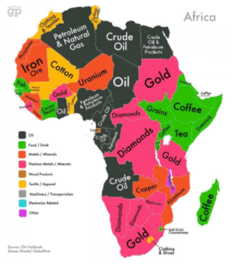
What could we question?
Which biomes can you identify in Africa? Why was trade important to the Empire of Mali? What is desertification? What might farmers in Madagascar be concerned about? What would you teach someone who didn’t know anything about Kenya?

Natural resources of Africa
Mansa Musa’s route to pilgrimage
Geography Knowledge Organiser
Unit of Work: Africa –Human Geography
Year Group: 5 Term: Summer A
Key figures:

