Key Vocabulary | Definition
foetus | An unborn human more than eight weeks after conception
gestation period | The time in which a foetus develops, beginning with fertilization and ending at birth. It lasts nine months in humans.
adolescence | The period following the onset of puberty during which a young person develops from a child into an adult.
puberty | The period during which adolescents reach sexual maturity and become capable of reproduction.
hormone | A chemical released in a gland that travels to other parts of the body where it helps control how cells and organs do their work.
growth stage | Infancy, childhood, adolescence, and adulthood are human growth stages before old age.
Science Knowledge Organiser
Unit of Work: The Human Body
Year Group: 5 Term: Summer A
Key figures:

Gestational Periods
Mouse | Dog | Polar Bear | Human | Elephant
20 days | 2 months | 8 months | 9 months | 21 months
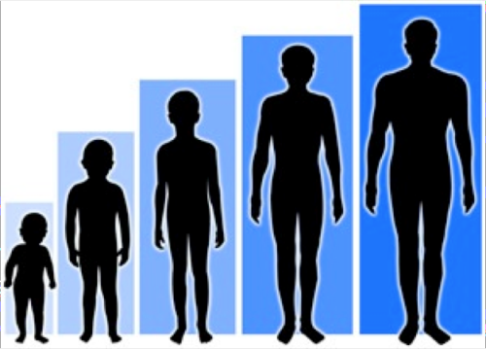
What could we question?
At what point can humans begin to reproduce?
What age do humans stop growing?
What happens to the muscles and bones during puberty?
What physical changes for females/males go through during puberty?
What are the different types of gland humans have?
What are the jobs of these glands?

