**RE Knowledge Organiser**

*Year Group:* **5** *Term:* **Summer B**

*Unit of Work:*

**Religion in the Local Area**

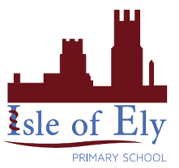

Key figures:

**Key Vocabulary:**

**Monks** – A member of a religious community

**Monastery** – occupied by a community of monks

**Community** – A group of people living in the same place or having a particular characteristic in common.

Cathedral = The principal church of a diocese, with which the bishop is officially associated

K**ey figures**

Etheldreda – Founded the first Christian community in Ely

Hereward the Wake

Oliver Cromwell

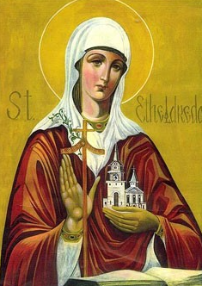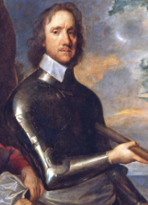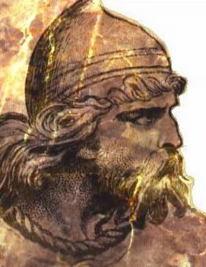

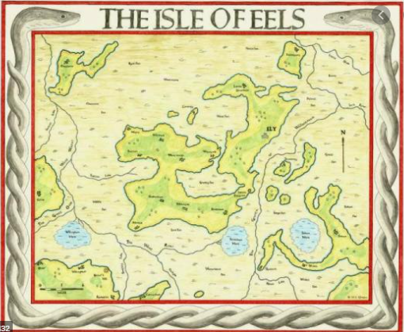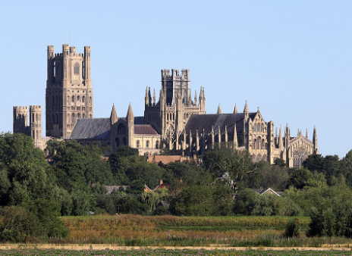

**What could we question?**

Which is the first known religion in Ely? What events occurred due to religious disputes? How was Ely Cathedral built? Who built Ely Cathedral? Why was Ely Cathedral built? Which religious communities are there in our local area? How do they impact and influence in our local community?