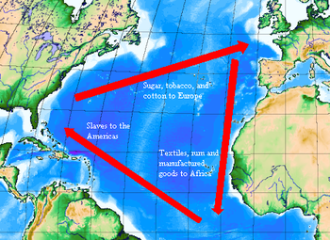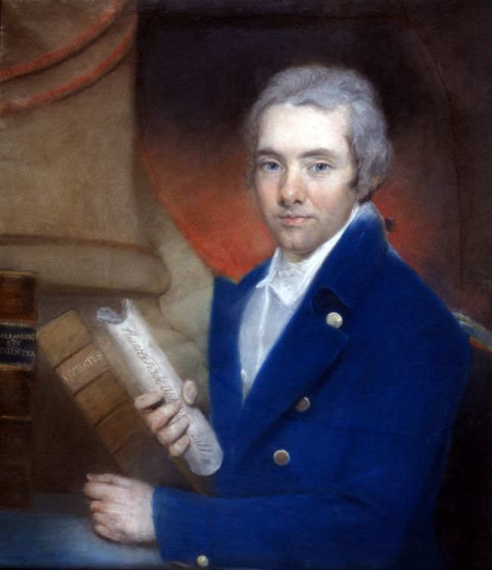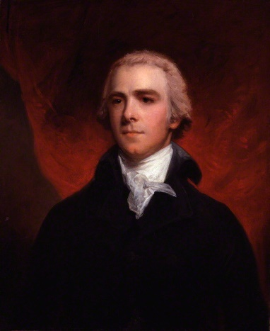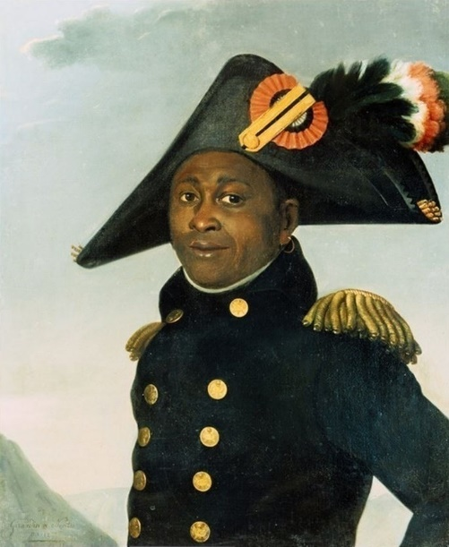

**The Transatlantic Slave Trade:**

The transatlantic slave trade is sometimes known as the 'Triangular Trade', since it was three-sided, involving voyages: from…:

**. Europe to Africa.**

**. From Africa to the Americas**

**. From the Americas back to Europe.**

**Key Figures:**

. **Toussaint L’Ouverture –** A former slave who led the revolt against the French and became leader of Saint-Dominque (Now Haiti).

. **William Wilberforce –** British Politician and founder of the Committee for the abolition of slave trade.

. **Zachary Macaulay –** Former Plantation manager and later abolitionist.

**Key Vocabulary:**

**. Transatlantic Slave Trade** – The forced migration of millions of people from Africa to the West from the middle of the 15th century to the end of the 19th century.. **Enslaved Africans** – A human being classed as property, who is owned by another person and who is forced to work for nothing. (*To refer to a person who was enslaved as a ‘slave’ strips them of their identify- therefore, the term ‘Enslaved Africans’ should be used).*

**. Atlantic Passage** – Also known as the ‘middle passage’, the part of the trade where Africans, densely packed onto ships, were transported across the Atlantic to the West Indies.

**. Plantation** – Usually a large farm or estate, especially in a tropical country, on which cotton, tobacco, coffee, sugarcane, or the like is grown.. **Abolitionists** - Someone who wanted to end slavery.



**History Knowledge Organiser**

***Unit of Work:* Abolitionism**

***Year Group:* 5 *Term:* Summer B**

Key figures: