. Benin Ivory Salt Cellar,

. Nigeria (Edo peoples)

. 17th century

. British Museum

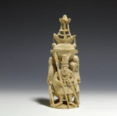

. Benin Plaque

. Nigeria (Edo peoples)

. 16th century

. British Museum

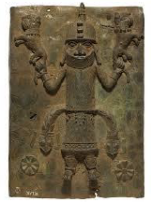

Map of West Africa (including all countries).

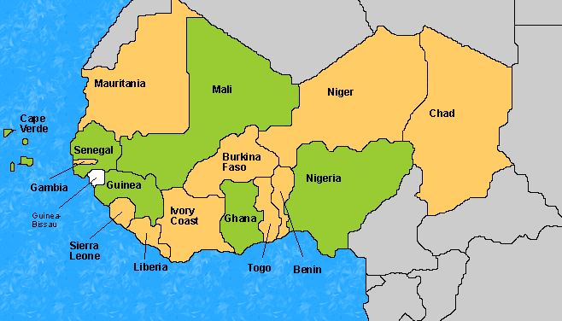

. Benin Ivory Mask of Queen Mother

. Nigeria (Edo peoples)

. 16th century

. British Museum

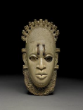

. Antelope Headdress

. Mali (Bamana peoples)

. 19th century/early 20th century

. Metropolitan Museum of Art, U.S.

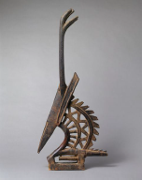

**Key Vocabulary:**

**. Peoples –** Members of a particular nation or community.

**. Ceremony –** A social or religious occasion often celebrating a particular event.

**. Bamana peoples –** A group of peoples living mainly in Mali, Western Africa.

**. Headdress –** A covering for the head, especially worn in ceremonies.

**. Edo peoples –** A group of peoples living mainly in southern Nigeria.

**. Benin City –** A city in southern Nigeria, West Africa. Benin City flourished from the 14th-17th centuries as the centre of the Benin Kingdom.

**. Plaque –** A flat, decorated slab, often square or rectangle that is fixed, to a wall or other surface and remembers an event or a person.

**. Relief –** Where sculptures stick out from a flat surface, rather than being made all the way around.

**. Cast –** The process of making an object by shaping liquid metal in a mould.

**. Brass –** A metal made by mixing two other metals, copper and zinc.

**. Ivory –** A hard, white substance, made from the tusks of elephants, which can be carved.



**Art Knowledge Organiser**

***Unit of Work:* Art from Western Africa**

***Year Group:* 5 *Term:* Summer B**

Key figures: