Key Vocabulary: | Definition:
Industry | Activity where raw materials are changed into goods that can be used and traded.
Aboriginal People | People living in Australia from the earliest times, before the arrival of settlers or colonists.
Colony | A country or an area under the control of another country and occupied by settlers from that country.
Settler | A person who has moved, with other people, to live in a new country or area.
Maori | People living in New Zealand from the earliest times, before the arrival of settlers or colonists.
Commonwealth | A group of countries that used to be part of the British Empire, but now voluntarily work together on issues such as human rights.
Biome | A community of plants and animals that have shared characteristics due to the environment they live in.
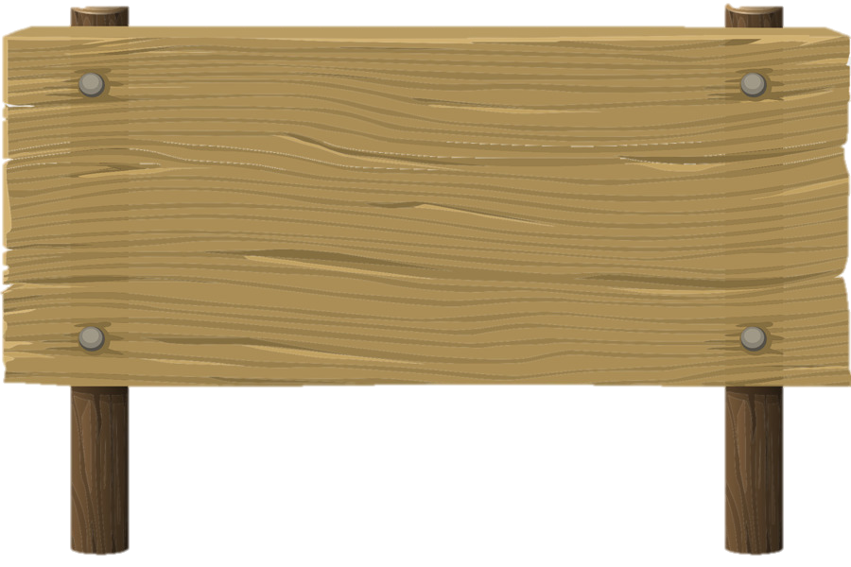
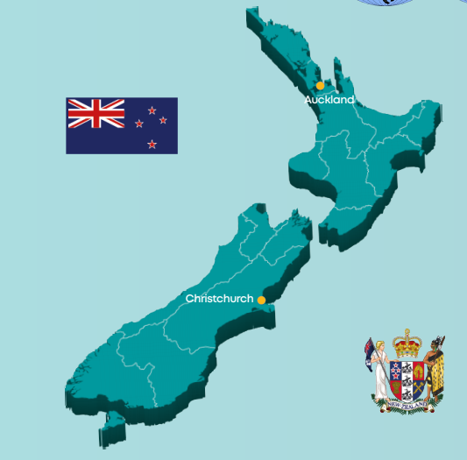
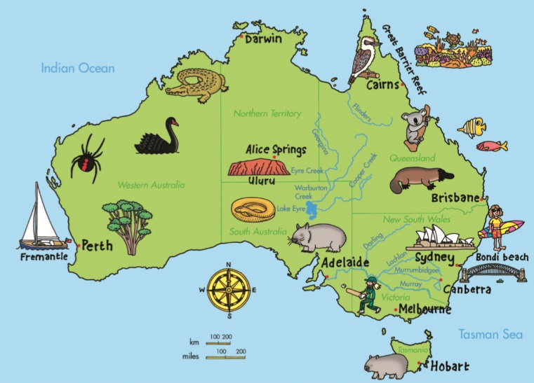
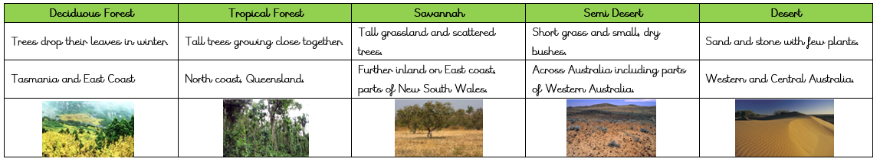
Geography Knowledge Organiser
Unit of Work: Australia, New Zealand and the South Pacific
Year Group: 5 Term: Summer B
Key figures:

