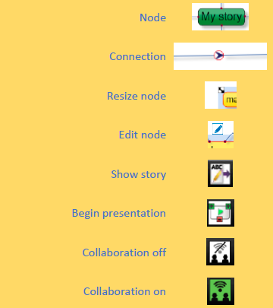

**Key Vocabulary:**

**Audience - People giving attention to something.**

**Collaboratively - Something that is produced by, or involves, two or more parties working together.**

**Concept – An idea.**

**Concept Map - A tool for organising and representing knowledge. They form a web of ideas which are all interconnected.**

**Connection - A relationship or link between two nodes or ideas.**

**Idea - An opinion or belief.**

**Node – A way to represent concepts or ideas.**

**Thought - An idea or opinion produced by thinking or occurring suddenly in the mind.**

**Visual - A picture, piece of film or display used to illustrate or accompany something.**

**What could we question?**

What is a concept map?

How is information arranged on a concept map?

How does a concept map help share ideas?

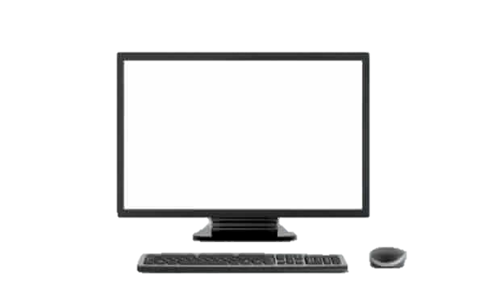

**Computing Knowledge Organiser**

***Unit of Work:* Concept Mapping**

***Year Group:* 5 *Term:* Summer B**

Key figures: