Knowledge Organiser
Year 3 – Spring Term B
Science – Plants
Joseph Banks – A botanist who travelled the world and gathered over 30,000 specimens of plants. | George Washington Carver – A botanist known for his work on replenishing soil by planting peanuts and sweet potatoes.
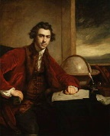 | 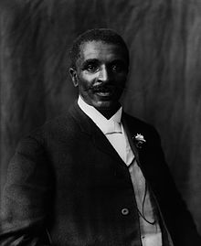

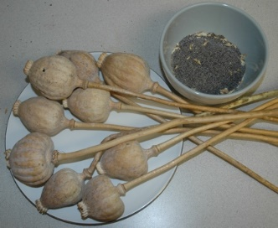
Key Vocabulary | Definition
Plant | A living thing that grows in the earth and has roots, leaves and a stem e.g. grass, trees, bushes, flowering plants.
Root | The part of a plant that acts as an anchor, fixing the plant into the ground. Roots also absorb water to help the plant to grow.
Stem | The part of the plant that grows above the ground. The leaves and flowers grow from it. The stem is also used to transport water around the plant.
Leaves | A plant’s leaves absorb sunlight and turn it into energy that the plant uses to grow.
Flowers | The part of a plant that bears the seed.
Nutrients | Goodness required for life and growth. Plants absorb nutrients from the soil.
Absorb | To take in or soak up.
Pollination | The transfer of pollen from one part of a plant to another.
Dispersal | Spreading things out over an area, seeds do this to help to reproduce.

Poppy seeds are dispersed from a ‘pepper pot’ head, when the wind blows the seeds shake out.
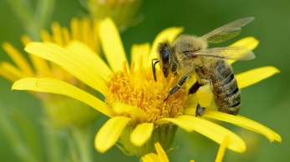
Many flowers rely on animals to help with pollination by moving pollen from one flower to another.

