Artists
Paul Cézanne | 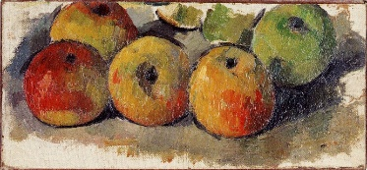
Jacob Ruisdael | 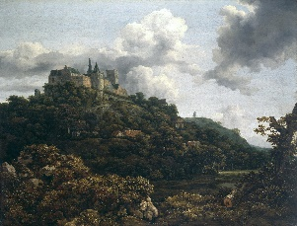
Henri Rousseau | 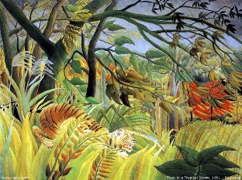
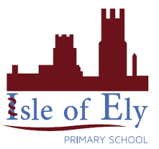
Knowledge Organiser
Year 3 – Spring Term 2
Vocabulary
Collage | A piece of art made by sticking various different materials such as photographs and pieces of paper or fabric on to a backing.
Landscape | everything you can see when you look across an area of land, including hills, rivers, buildings, trees, and plants.
Fens | A low and marshy or frequently flooded area of land.
Still life | A piece of art that is made about inanimate subject matter, typically commonplace objects which are either natural (food, flowers, dead animals, plants, rocks, shells, etc.) or man-made (drinking glasses, books, vases, jewelry, coins, pipes, etc.)
Art- Types of Paintings: Landscapes and Still Life and Types of Art: Collage

Primary/Tertiary colour wheel
