Artists
Angelica Kaufman  Ariadne Abandoned by Theseus (1774) | 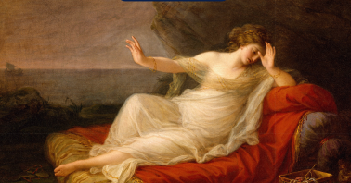
Antonio del Pollaiuolo  Apollo and Daphne (c.1432-1498) | 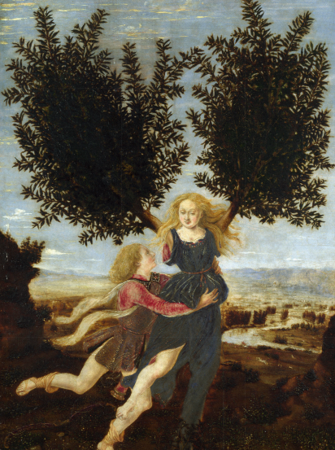
Knowledge Organiser
Year 3 – Summer Term 2
Art- History Painting

Vocabulary
History painting | Paintings that tell stories from myths, classical history and the Bible
Myth | A traditional story made up in the past, often to explain an event, belief or custom
Mythological paintings | Paintings relating to or based on myths
Narrative | A piece of art that tells a story with colour and lines, instead of words
Classical | Something that is from ancient Greek or Roman culture
Character | A person or an animal in a piece of narrative art
Characteristic | An important thing about thing or a person which makes them what they are
Setting | The place where a story takes place
Minotaur | A monster which is half bull and half man

