7 ‘I am Statements’.

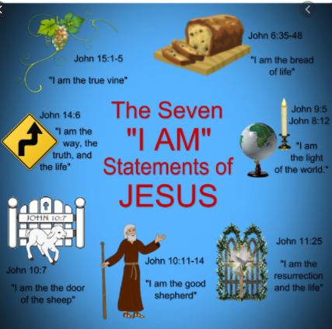
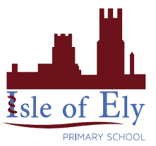
Knowledge Organiser
Year 3 – Summer Term 2
RE- Jesus the Bread of life
Vocabulary
Jesus | God the son- part of the holy trinity, the God who was on Earth.
Gospel | The record of Jesus’ life and his teachings in the New Testament
Spiritual | A feeling or belief in religion
Holy Trinity | Three ‘God’ in one.
Sin | An immoral act considered to go against the teachings or laws of religion
Sacrifice | To give up something for the sake of other.
Shepherd | A man who looks after sheep as his job.
flock | A group of sheep – used here to describe Jesus’ followers.
New Testament | Second part of the Christian Bible.

