Ely
Human features | Physical Features
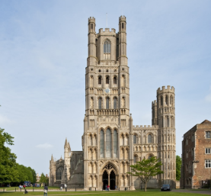  Ely catherdral begun construction in 1080 and was completed I nthe early 14th century. A fun fact about Ely Cathedral is that the parts made of wood could never be rebuilt today beavause there are no trees large enough!  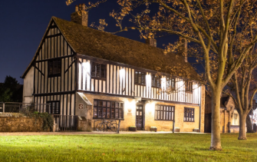  Oliver Cromwell was an English general who led the army against King Charles in the English Civil war. In 1649 Oliver Cromwell was given the title of Lord’s Protector and was offered the title of Kin! He refused this title but still has lots of power as a ruler. His house still stands in Ely and is dated back to 1215- that’s 805 years old! | 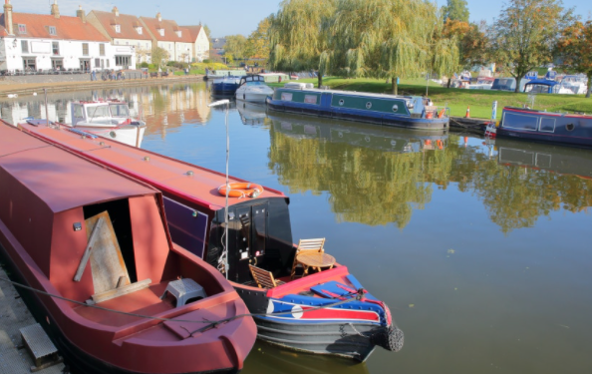  The River Great Ouse is the longest of serval rivers named ‘Ouse’ in England. It is 143 miles long and the fourth longest river in the United Kingdom! The River Great Ouse runs right through the centre of Ely and hosts lots of fun activities, such as sailing, kayaking and much more. The river is a central point for activity within the city of Ely.
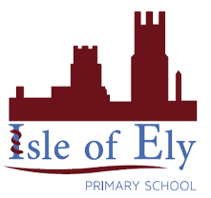
Knowledge Organiser
Year 3 - Autumn Term A
Vocabulary
city | A large town that has a university or a cathedral. Ely is a city because it has a cathedral.
town | A large group of houses, shops and buildings where people live and work. Town are larger than villages but smaller than cities. Soham is a town.
village | A small group of houses, perhaps with a few shops, that are often in the countryside. Wicken Fen is a village.
human features | Features of land that are impacted by human activity. Buildings and features that are manmade. Ely cathedral is a human feature.
physical features | Natural features of the land that have not been man made. The River Ouse is a physical feature.
England | A country in the United Kingdom. Ely is a city in England.
country | An area of land that is controlled by its own government.
county | A region of Britain or Ireland which has its own local government. Ely is within the county of Cambridgeshire.
Ordinance survey map | The official detailed map produced in England and Ireland, detailing roads as well as human and physical features.
Geography- The local area
Key Facts
- The River Great Ouse is 143 miles long
- The city Ely is named after the Eels found in the local fenlands.
- Ely has a population of 20,112
- Ely is surrounded by fenlands and wetlands, which makes it a brilliant place for farming!
- In mediaeval times, Ely was a patch of high ground amongst miles of fenland. Over time, humans have imposed human features such as ditches and pumps to drain the land and build on.

