Ancient Greece
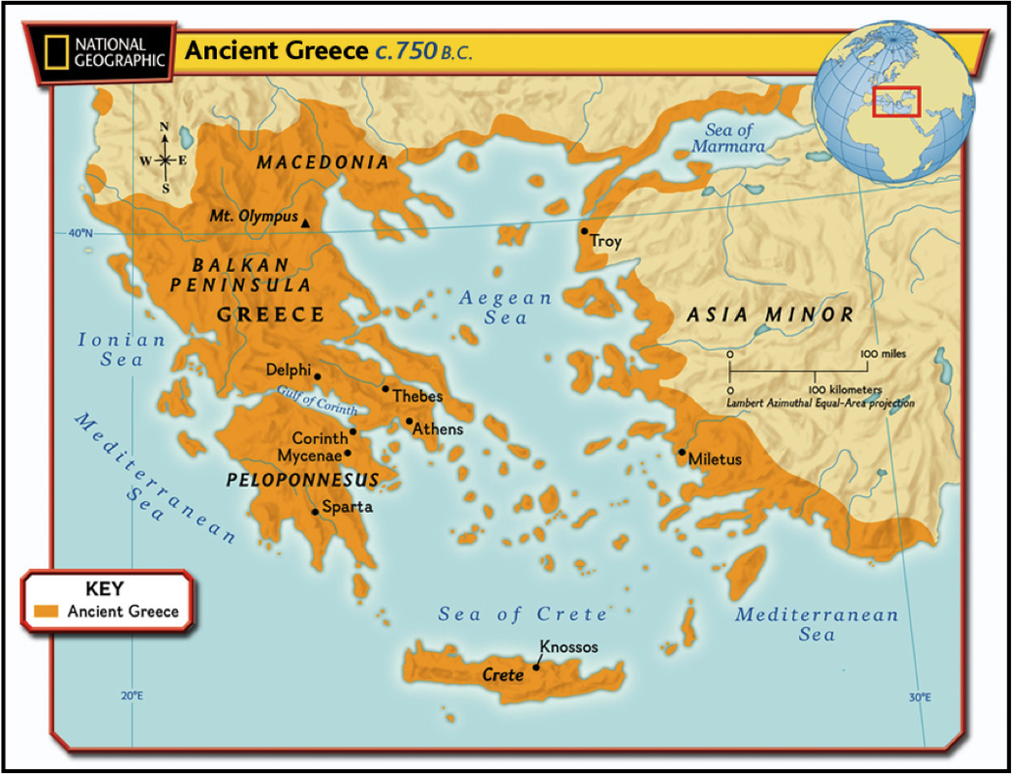
Knowledge Organiser
Year 3 - Autumn Term A
Vocabulary
Ancient | A period of history that is thousands of years in the past.
Modern | Present time or recent times.
City-state | A city-state is an independent city — and sometimes its surrounding land — which has its own government, completely separate from nearby countries.
Tragedy | A very sad event or situation, especially one that involves death.
Theatre | A building with a stage in it, on which plays, shows, and other performances take place.
BC | You use BC in dates to indicate a number of years or centuries before the year in which Jesus Christ is believed to have been born.
AD | You use AD in dates to indicate the number of years or centuries that have passed since the year in which Jesus Christ is believed to have been born.
Trireme | An ancient Greek warship.
Warfare | The activity of fighting a war.
History - Ancient Greek Culture
Key Facts
- The Ancient Greeks lived about 3,OOO years ago.
- Ancient Greece was not a single country but was made up of many city states. The most famous are: Athens, Sparta and Corinth.
- The Minoans are the oldest Ancient Greek civilisation and originate from the island of Crete.
- The city states used to fight each other.
- The Olympics began in Ancient Greece and were a time of peace when warring states could try to come to a peaceful agreement. The original games were held in Olympia in 776 BC and were part of a religious ceremony.

