Types of rock
Sedimentary | Igneous | Metamorphic
Sandstone  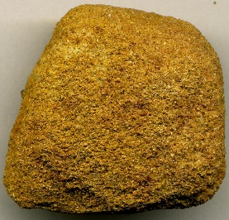 | Granite  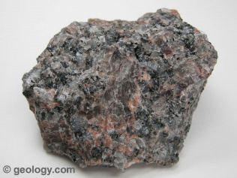 | 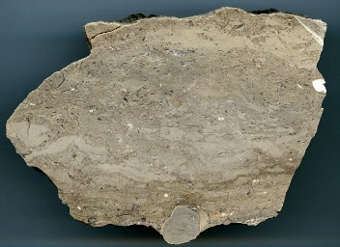  Marble
Knowledge Organiser
Year 3 - Spring Term A
Vocabulary
Rock | A hard, solid material that is made of minerals and is found in nature.
Mineral | A solid, natural material that does not come from a living thing.
Permeability | The ability of water to flow or sock through a rock.
Sedimentary | Rock formed when sediment is pressed together over time. Formed over a long period of time (e.g. shale, limestone, sandstone)
Igneous | Rock formed by the cooling and hardening of hot magma or lava. Formed by volcanoes! (e.g. basalt, granite).
Metamorphic | Rock formed when any type of rock goes through changes caused by extreme heat and pressure (e.g. marble, slate).
Soil | The top layer of the ground, in which plants grow: dirt.
Humus | Bits if decaying plants and animals found in soil.
Fossil | The remains of a plant or animal that turned to stone over a long period of time. Mostly found in sedimentary rock.
Science – Types of rocks and their properties
Fossils
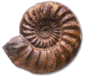
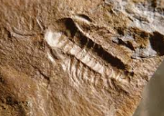
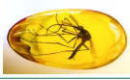
After an animal dies, the soft parts of its body decompose leaving the hard parts, like the skeleton, behind. This becomes buried by small particles of rock called sediment. As more layers of sediment build up on top, the sediment
around the skeleton begins to compact and turn to rock.
Sometimes plants and animals can be
fossilised in other substances such as amber.

Types of soil
Clay | Clay is sticky and does not have much air. It can hold a lot of water. It cracks when it dries.
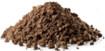  Loam | Loam soil is a mixture of sandy soil, clay soil and humus. It is great for growing plants and crops as it holds a bit of water but not too much.
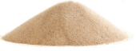  Sandy | Sandy soil is dry with lots of air gaps so water drains through easily.
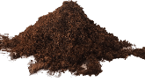  Peat | Peat is different from other soils because it does not contain any rock particles. It is made from very old decaying plants and is dark, crumbly and rich in nutrients (chemicals plants need to grow)

