Forces and Motion
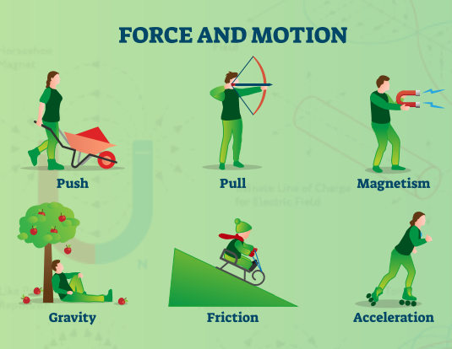
Knowledge Organiser
Year 3 – Summer Term B
Vocabulary
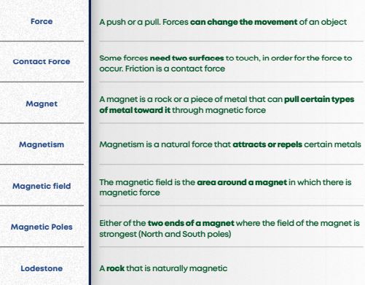
Science- Forces and Magnets
Magnets
