Listening to and performing pop songs about friendship. |  | Pulse
Pop music usually has a strong pulse which means it is easy to dance 'in time' with the music. It often has a simple melody that is easy to sing along to. |  | The heartbeat of the music. Sometimes called the 'beat'.  We can clap along in time, we can move our bodies in time, we can march in time to the beat of the music.
Instruments and Body Percussion |  | Rhythm
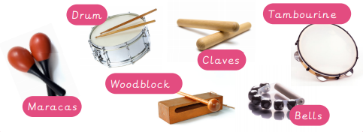  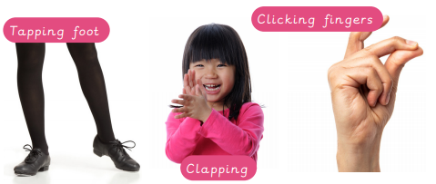 |  | 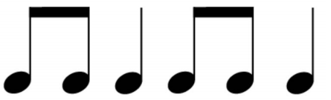  A pattern of long and short sounds
Knowledge Organiser
Autumn Term 1
Music – Pulse and Rhythm
Vocabulary
In Time | Clapping, dancing, singing or marching at the same speed as the music.

