Mouse Skills
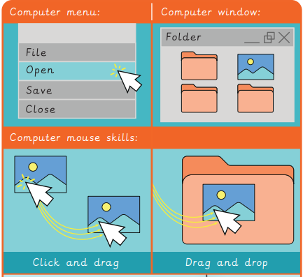

e-Safety |  | Using a Mouse
Staying safe online means:  Being kind to others  Knowing who to talk to if something worries you online  Not sharing personal details  Not clicking on buttons or pictures that pop up on your screen |  | 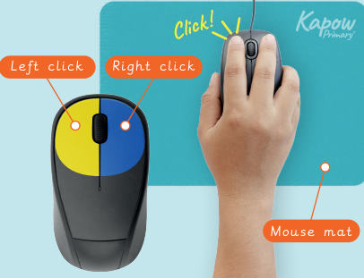
Knowledge Organiser
Autumn Term 1
Computing – Improving Mouse Skills

Vocabulary
Computer | A digital device e.g. desktop, laptop or tablet
Mouse | A small device which moves the cursor around the screen
Keyboard | Keys which operate a computer
Sketchpad | Drawing application for computers
Clipart | Simple pictures and symbols made for computers
Password | A secret word or phrase which keeps your online accounts safe
Software | Programs used by a computer
Menu | A list of commands or options on a screen

