The Royal Family Tree
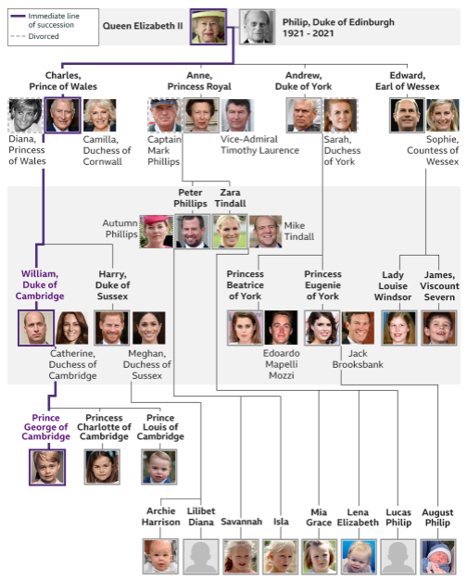

Local History |  | Artefacts
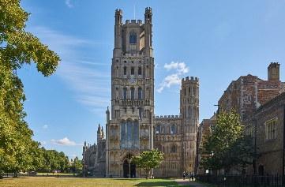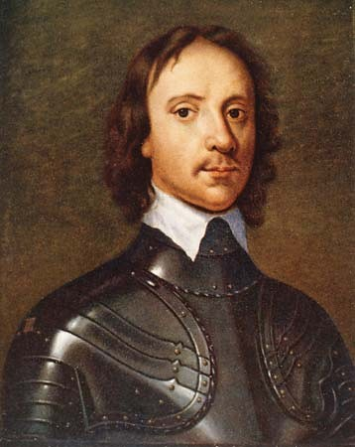 |  | 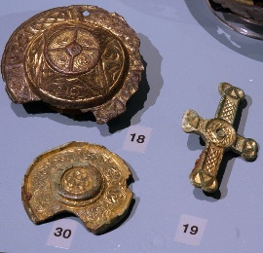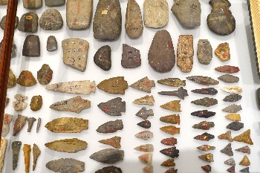
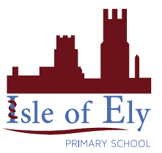
Knowledge Organiser
Autumn Term 1
History – Discovering History

Vocabulary
Past | Things that have already happened – can be recent or a long time ago
Present | Now
History | Things that have happened in the past
Historian | A person who studies the past by looking at books, paintings and photographs
Family tree | A picture showing how people are related to one another in a family
Related | Being in the same family
Relation | A person who is part of your family
Archaeologist | People who find things that belonged to people a long time ago and learn from them
Artefact | Something old which can tell us about the past and was made by a human
Source | Where something comes from
Information | Facts and things we learn

