The Bible
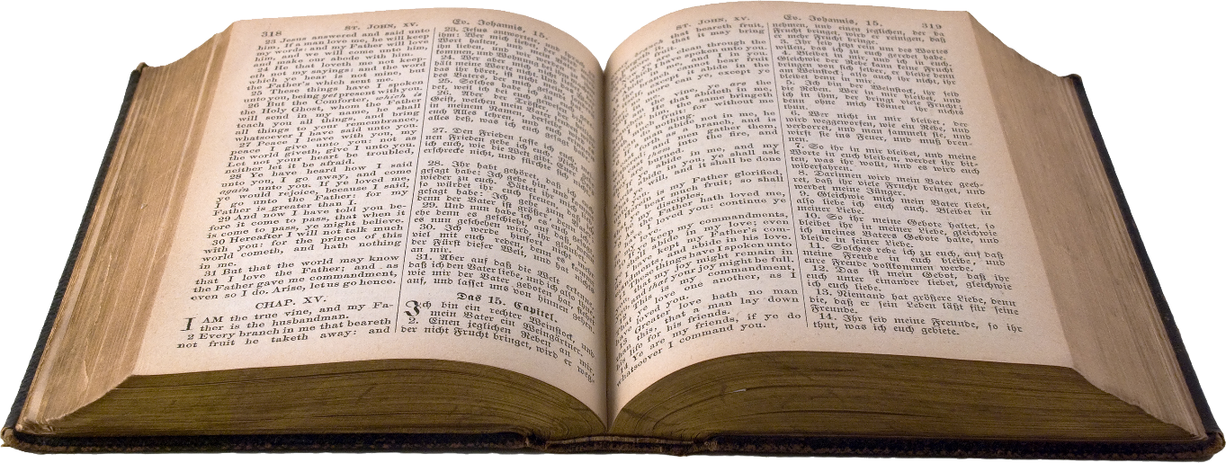

Important to Christians because it teaches them about God and Jesus
Read in church or at home
Helps Christians think about their behavior, e.g. being thankful, saying sorry, forgiveness

Being a Christian |  | Bible Stories
Christian families may:  Go to church  Read the Bible  Pray  Say Grace before meals |  | There are lots of Bible stories including:  Creation  Moses  David and Goliath  Daniel in the Lion’s Den  Jonah
Knowledge Organiser
Autumn Term 1
RE – Christianity: Beliefs and God

Vocabulary
Bible | A collection of books which delivers messages from God and Jesus to Christians
Worship | Expressing feelings towards a God
Faith | Belief in a something e.g. a religion, or someone
God | Christians believe God created and rules the universe and guides them
Holy | Related to God or religion
Prayer | Requests or thanks expressed to God
Hymn | A religious song or poem to praise God

