Robert Walpole |  | Elections
The first Prime Minister of Great Britain.  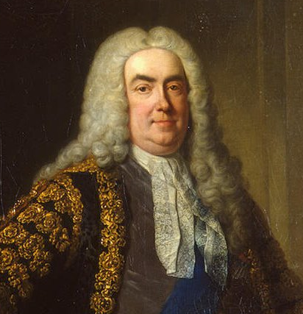 |  | Adults choose who they want to be in the government – this is called a vote.  Adults vote by going to a polling station.  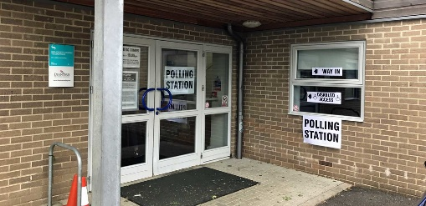  They put a cross in a box to show who they want to vote for.  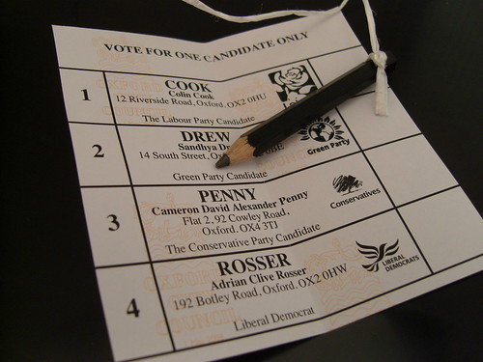  The votes are put in a ballot box.  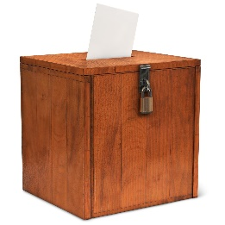
Rishi Sunak
The current Prime Minister of Great Britain.

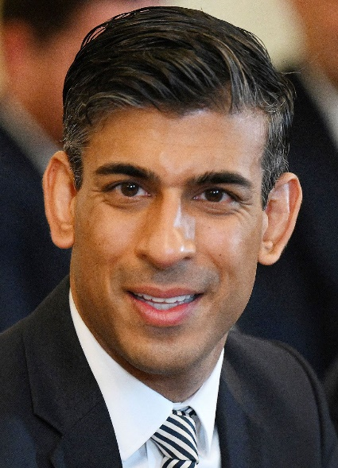
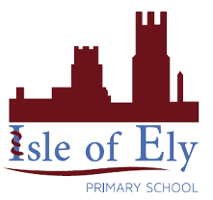
Knowledge Organiser
Summer Term 1
History – Parliament and Prime Ministers
Vocabulary
Parliament | A group of people of elected people who make laws for their country.
Budget | Estimating how much money will be spent and earned during a set time.
House of Parliament | The place where government meet. Made up of the House of Lords and the House of Commons.
Prime Minister | The head of an elected government.
Government | A group of people with the authority to govern, or rule, a country.
Vote | Choosing between two or more candidates (people) through a ballot.
Election | A process during which people vote to choose a person or people to represent their area in parliament.
Polling Station | A building e.g. a school or a village hall, where people go to cast their votes in an election.
Party | A political party is a group of people who share the same views about how a country should be run. Usually a country is run by the political party who win the most votes in an election.
Ballot Box | A special, sealed, box in which votes are placed during an election.

