Untuned percussion
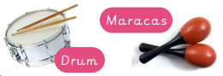  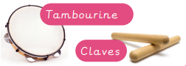 |  | 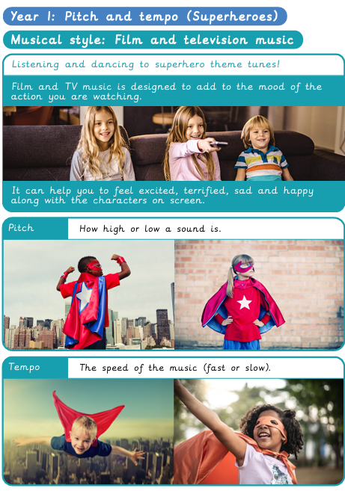
Tuned percussion
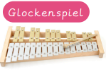
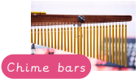
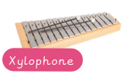
Knowledge Organiser
Summer Term 1
Music – Pitch and Tempo (Superheroes)
Vocabulary
Pitch | How high or low a sound is.
Timbre | The ‘quality’ of a sound e.g. smooth, scratchy, twinkly.
Vocal sounds | Sounds made with your vocal chords, such as talking, singing, humming and shushing.
Dynamics | The volume of the music (loud or quiet).
Tempo | The speed of the music (fast or slow).
Accelerando | A musical term to describe when the speed of the music gets faster and faster.
Percussion instruments | Instruments which are played by shaking, tapping or scrapping with your hand or a beater.
Untuned percussion | Percussion instruments you cannot play a tune on.
Tuned percussion | Percussion instruments you can play tunes on.
Compose | To create or write an original (new) piece of music.

