Guru Gobind Singh |  | The 5 Ks
The tenth guru of Sikhism.  He was the last human guru of Sikhism.  Guru Gobind Singh transformed the Sikh faith, creating the Khalsa, the faithful Sikh community who wore visible symbols of their faith.  He declared the Sikh holy book as his successor instead of a human being. |  | Kesh – uncut hair  Kara – a steel bracelet  Kanga – a wooden comb  Kacchera – cotton underwear  Kirpan – steel sword  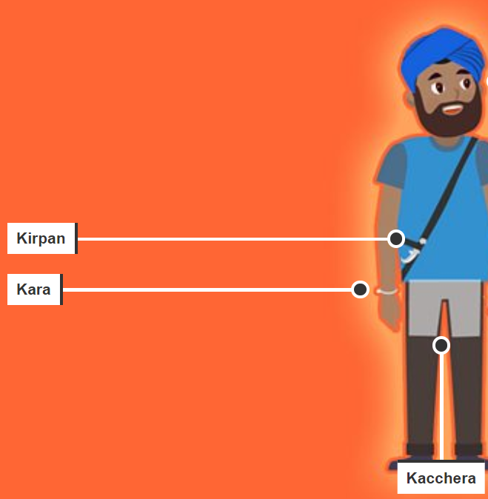  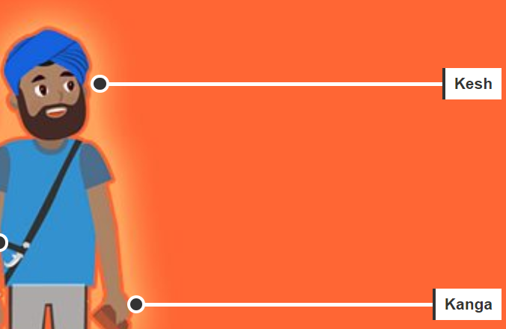
Amrit Sanskar
Takes place in the Gurdwara in the presence of the Guru Granth Sahib.

Candidates for initiation drink Amrit from the bowl and have it sprinkled on their hair and eyes.

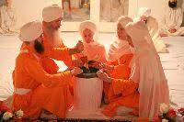
Knowledge Organiser
Summer Term 1
RE – Sikhism: Khalsa
Vocabulary
Khalsa | To be pure, to be clear. Refers to both a community that considers Sikhism as its faith, as well as a special group of initiated Sikhs.
Sewa | A willingness to serve others without thought for your wellbeing.
Amrit | A bowl of sugar and water.
Khanda | A double-edged sword which stirs the amrit.
Panj Pyare | The name for the amrit and khanda.
Amrit Sanskar | The ceremony Sikhs take part in to become part of the Khalsa.
The 5 Ks | Five items worn on the body of initiated Sikhs – like a uniform.
Guru | Teacher in the Sikh faith.
Guru Gobind Singh | The tenth Sikh guru.
Singh | Meaning lion. The name given to initiated male Sikhs.
Kaur | Meaning princess. The name given to initiated female Sikhs.

