Wheels |  | Axles
Wheels are on many objects, not just vehicles.  Have you seen any of these? |  | The wheels need to be attached to an axle. The axle needs to fit inside the axle holder but must not be attached to the axle holder otherwise the wheels will not turn properly.  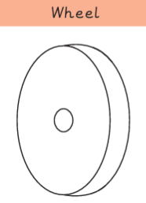  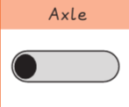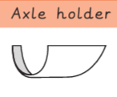  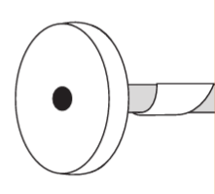
The wheels need to be round and balance the body of the vehicle.

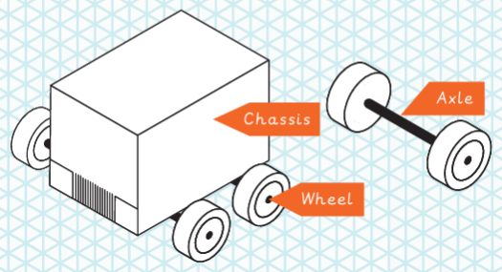
Knowledge Organiser
Summer Term 1
DT – Mechanisms: Wheels and Axles

Vocabulary
Accurate | Neat, correct shape, size and pattern with no mistakes.
Axle | A long straight rod which connects to a rotating part e.g. the wheels of a car.
Axle holder | The part of a mechanism which holds the axle steady.
Chassis | The body of a car.
Design | To make, draw or write plans for something.
Fix | To mend something so that it will work properly again.
Mechanic | A person who can build or mend vehicles or other machines.
Mechanisms | Parts of an object that move together to make something work.
Model | A practise version that lets you test out your idea and see how it will work and look.
Test | To find out whether something works as it should.
Wheel | A circular object that turns round. It can be fixed to a vehicle like a car or bicycle to allow the vehicle to move easily over the ground.

