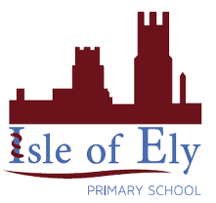 Knowledge Organiser

Year 2 - Summer Term A

**Art – Types of Painting: Portraits and Self-Portraits**

|  |  |
| --- | --- |
| **Key Vocabulary** | **Definition** |
| portrait | A piece of art work showing a person |
| self-portrait | A portrait that an artist creates of themselves |
| facial features | Eyes, nose, mouth, ears |
| skin tone | The shades of a person’s skin |
| represent | How an artist shows what a person is like in a portrait |
| cubism | A way of painting and drawing where artists show more than one view of something in the same picture, like looking at many sides of a cube at once. |

|  |  |
| --- | --- |
| **Portraits** | **Artist** |
|  | Leonardo da Vinci, Mona Lisa, 1503-06 |

|  |  |
| --- | --- |
| **Self-Portraits** | **Artist** |
|  | Vincent Van Gogh, Self-portrait 1889 |
|  | Rembrandt van Rijn, Self-portrait, 1659 |
|  | Pablo Picasso, Self-portrait, 1907 |