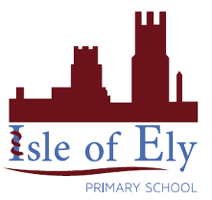
Knowledge Organiser
Year 2 - Summer Term A
RE– Islam
Key Vocabulary | Definition
Allah | the one and only God in Islam
Mecca | Mecca is a city in Saudi Arabia, which is the holiest city in Islam.
Prophet | Special messengers between Allah and the people.
Qur’an | The Islamic sacred book, believed to be the word of God as dictated to Muhammad. It is written in Arabic.
The five pillars of Islam | The five things a Muslim must do to live a good and responsible life.
Salaah | One of the five pillars of Islam, meaning prayer.
Mosque | A muslim place of worship.

