Knowledge Organiser
Year 2 – Summer Term A
Vocabulary
Appraisal | Listening carefully and considering aspects of the music.
Dynamics | A musical dimension indicating how loudly or quietly the music is being played.
Melody | Another name for tune.
Off-beat | The beat that is not the strong beat. If a piece of music has 4 beats in a bar i.e. 1, 2, 3, 4, beats 2 and 4 would be the ‘off’ beats.
Pitch | A musical dimension that describes the range of high and low sounds.
Pulse | The heartbeat or steady beat of a song/piece of music.
Rhythm | A musical dimension that describes the combination of long and short sounds to make patterns.
Tempo | A musical dimension that describes how fast or slowly the music is played.
Music – The Friendship Song

Listen
The following songs are going to be key music in this unit, the music all has a common theme can you guess what it might be?
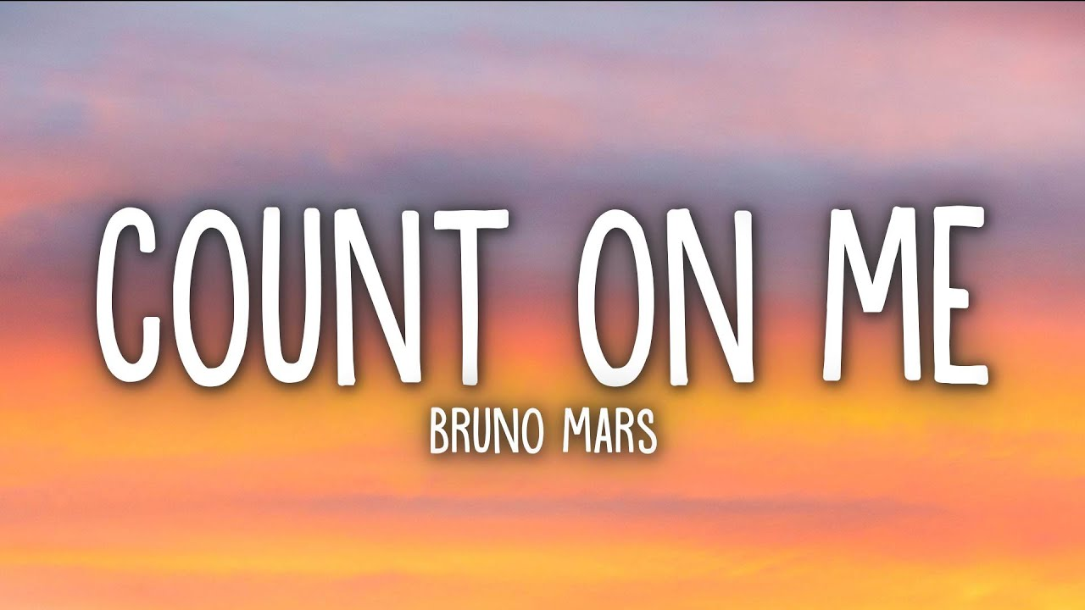

The pulse is the heartbeat of the music and is the same throughout this song.

