Knowledge Organiser
Year 2 – Summer A
Vocabulary
Adaptation | Many plants and animals have adapted so they suit a particular habitat.
Alive | A plant or animal that is alive moves, grows and reproduces.
Consumer | A consumer is a plant/animal that eats another plant or animal
Dead | Something that was a living thing but is no longer alive.
Food chain | A food chain is a diagram which shows us how animals are linked by what they eat, and what eats them
Habitat | A place where plants or animals live
Producer | Plants are called producers because they produce their own food. Most food chains start with a producer (plant) that is eaten
Microhabitat | A very small part of a bigger habitat, with a special feature such as woodlice living under stones in a garden
Science – Living Things in Their Environment

Earthworms help to break down dead matter and provide nutrients for the soil.

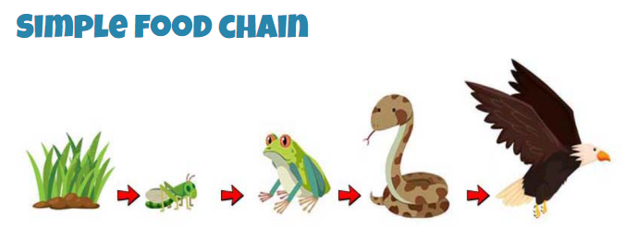

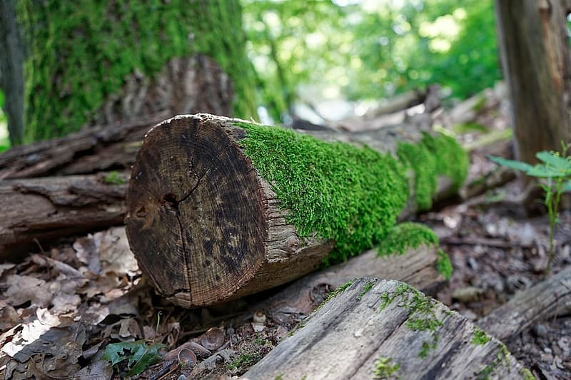
An example of a microhabitat, what animals do you think might live here?

