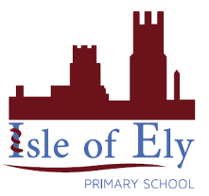
Knowledge Organiser
Year 2 - Spring Term A
Art – Types of Art: Murals

Vocabulary
mural | A piece of art that is painted or put onto a wall.
Leonardo da Vinci | A famous artist who created The Last Supper.
Michelangelo | A famous artist who was asked to paint the ceiling of the Sistine Chapel.
In Art this half term, we will be learning about murals. We will be learning what they are, where they are created and why they are created. We will also be learning about some famous artists who created murals. We will be making our own murals too!
We will recap our previous knowledge of line and colour to ensure we remember this from last term.

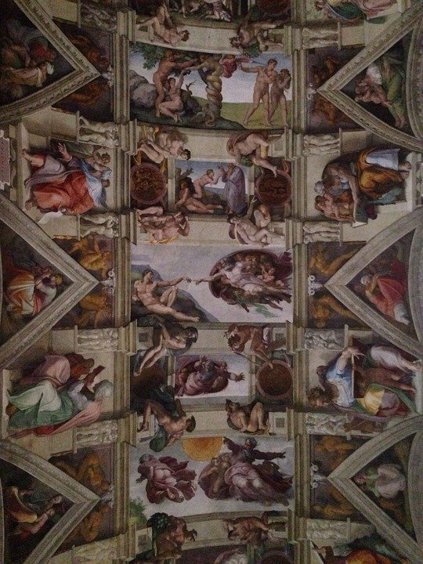
Famous Murals:

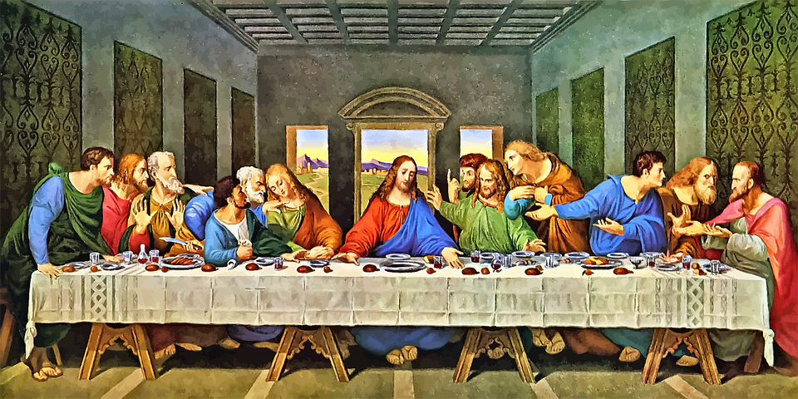

Where are murals created?
Why are murals created?

