Knowledge Organiser
Year 2 - Spring Term A
Vocabulary
Battery | A store of energy.
Circuit | A path which electricity flows around.
Conductor | An electrical conductor allows electricity to flow through it..
Electricity | Electricity is a form of energy that helps to make things work.
Electrical Current | The flow of electricity.
Electric Shock | If we allow electrical current to flow through our bodies it can hurt us.
Insulator | Are materials which can be reused for other purposes, some materials are easier to recycle than others.
Light Bulb | A piece of equipment that converts electrical energy to light energy.
Switch | Light can travel through it meaning that you can see what is on the other side of it
Wire | A thin piece of metal (usually covered in plastic) that allows electricity to flow through it..
Science – Electricity

Simple Circuit
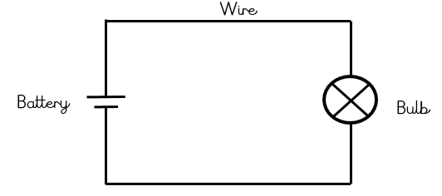

Electrical Symbols
Battery | Bulb
Wire | Switch

