Knowledge Organiser
Year 2 - Spring Term A
Geography – UK: Weather and Climate
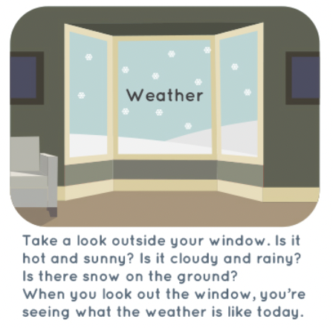
Vocabulary
Climate | Climate is the average measurements of temperature, wind, humidity, snow, and rain in a place over the course of years.
Continent | A continent is a large solid area of land. Earth has seven continents.
Country | A country is land that is controlled by a single government.
Europe | One of the seven continents of the world. This continent includes the United Kingdom, the country we live in.
Precipitation | Water that falls to the earth as hail, mist, rain, sleet, or snow.
United Kingdom (UK) | A country in Europe made up of four different parts, England, Scotland, Wales and Northern Ireland.
Weather | Weather is sunshine, rain, snow, wind, and storms. It's what is going on outside right now

The United Kingdom
