Knowledge Organiser
Year 2 - Spring Term A
Music– Musical Me
Vocabulary
Beat | A blow or a stroke made again and again.
Dynamics | Dynamics means how quietly or loudly a piece of music should be played.
Melody | When we use lots of different pitches in a row
Notation | Music notation is a visual record of musical sound
Pulse | A Pulse is a steady beat like a ticking clock or your heartbeat.
Rhythm | Rhythm refers to the length of time between each major "beat",
Timbre | The quality of sound that makes one voice or instrument different from another.

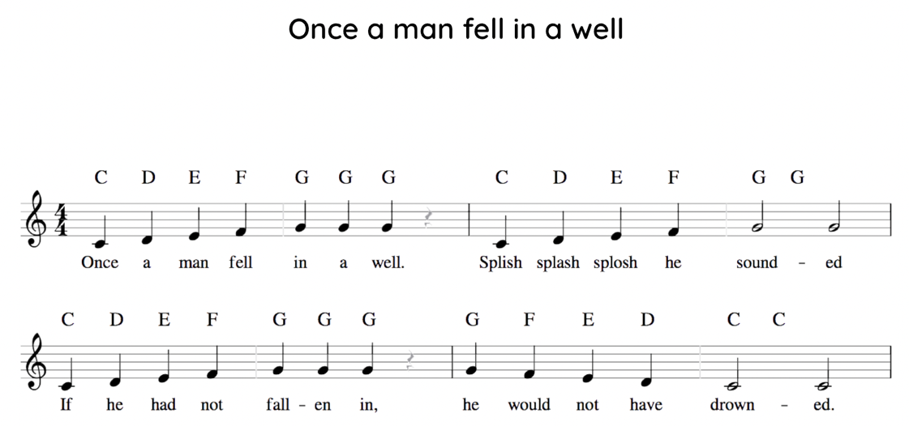
Music Notation

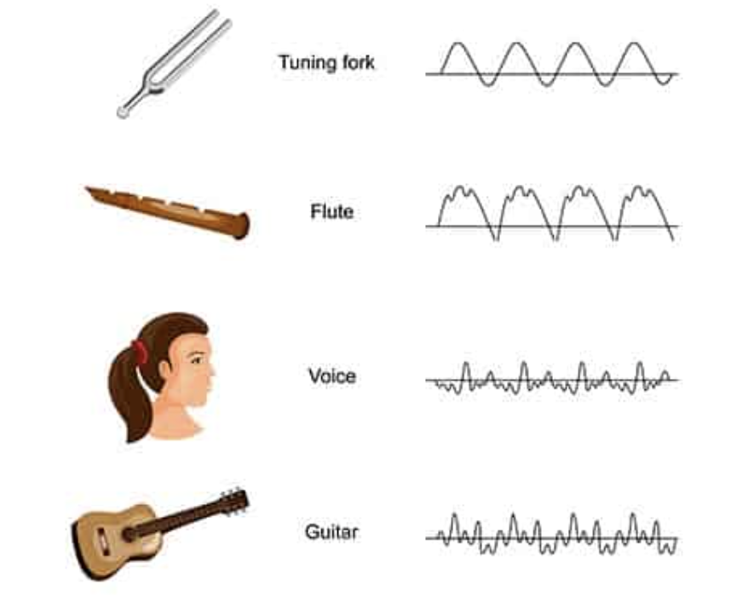
Timbre

