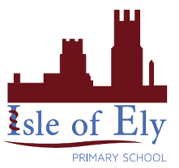
Knowledge Organiser
Year 2 - Spring Term A
Vocabulary
Islam | Islam is a very large religion that started in the 7th century
Muslim | A person who follows Islam
Allah | This is the name of the one and only God in Islam
Prophet | They are people that spread God’s message on Earth
Qur’an | The ‘divine’ or ‘holy’ book in Islam
Arabic | The language that the Qur’an is written in
5 Pillars | The most important Muslim practices that each Muslim must follow
RE – Islam: Beliefs
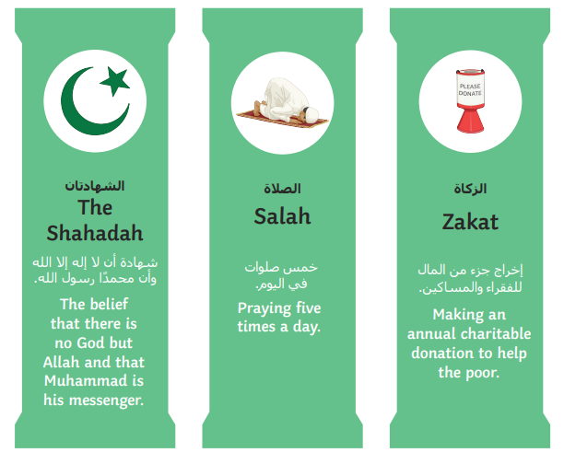

Mecca- where Islam began
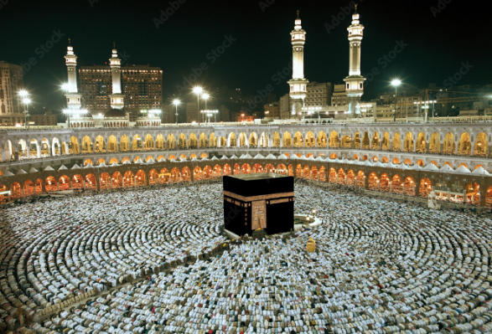
The Qur’an- the holy book
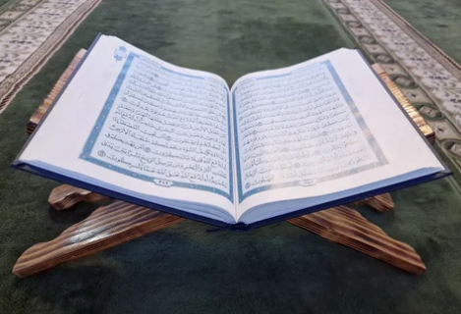
Arabic Script