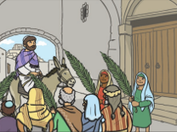
Holy Week
Holy Week is the week leading up to Easter. The Easter story is very important to Christians as it reminds them of Jesus’ death and celebrates his resurrection. There are four important days during Holy Week: Palm Sunday, Maundy Thursday, Good Friday and Easter Sunday.
Unit: Christianity, Easter
Term: Spring 1

Vocabulary:
Easter | The oldest and most important Christian Festival.
Christians | People who follow the religion of Christianity.
Jesus | The son of God.
Resurrection | When Jesus came back to life.
Disciples | The twelve followers of Jesus.
Symbolise | When something stands for something else.
Betray | To be unfaithful or break a promise to someone.
Holy Communion | A special service in church, where Christians share bread and wine.
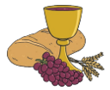
Palm Sunday
Palm Sunday marks the start of the holy week. Christians remember when Jesus rode into Jerusalem on a donkey and was welcomed by people waving palm leaves and placing them on the ground in front of him, palm leaves symbolise goodness and well-being.
Maundy Thursday
On Maundy Thursday the story of the last supper is remembered. Maundy, comes from a word that means command. At his last supper, Jesus knew that this would be his last supper and that one of his disciples (Judas) would betray him.
The Last Supper
During the last supper, Jesus shared some bread and wine with his disciples. Jesus said the bread was his body and the wine was his blood. During Holy Communion, Christians re-enact this special moment from the last supper.

