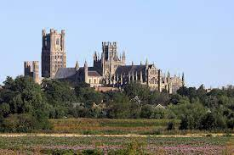
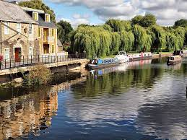
Human feature - Features of land that are impacted by human activity. Buildings and features that are manmade. Ely Cathedral is a human feature.
Physical feature - Physical features of the land that have not been man made. The River Ouse is a physical feature.
Unit: Features of Ely and the Surrounding Area
Term: Spring 1

Vocabulary:
fens | An area of low-lying, naturally boggy land in the East Anglia.
ditch | A natural or manmade trench between fields that help drain water and prevent flooding.
Fertile land | Land that is rich in nutrients and good for growing plants and crops.
city | A large town that has a university or a cathedral. Ely is a city because it has cathedral.
town | A large group of houses, shops and buildings where people live and work. Towns are larger than villages but smaller than cities. .
village | A small group of houses, perhaps with a few shops, that are often in the countryside.
hamlet | Small settlement, generally smaller than a village and strictly, a settlement without a church. Typically located in very rural areas.
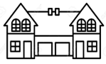
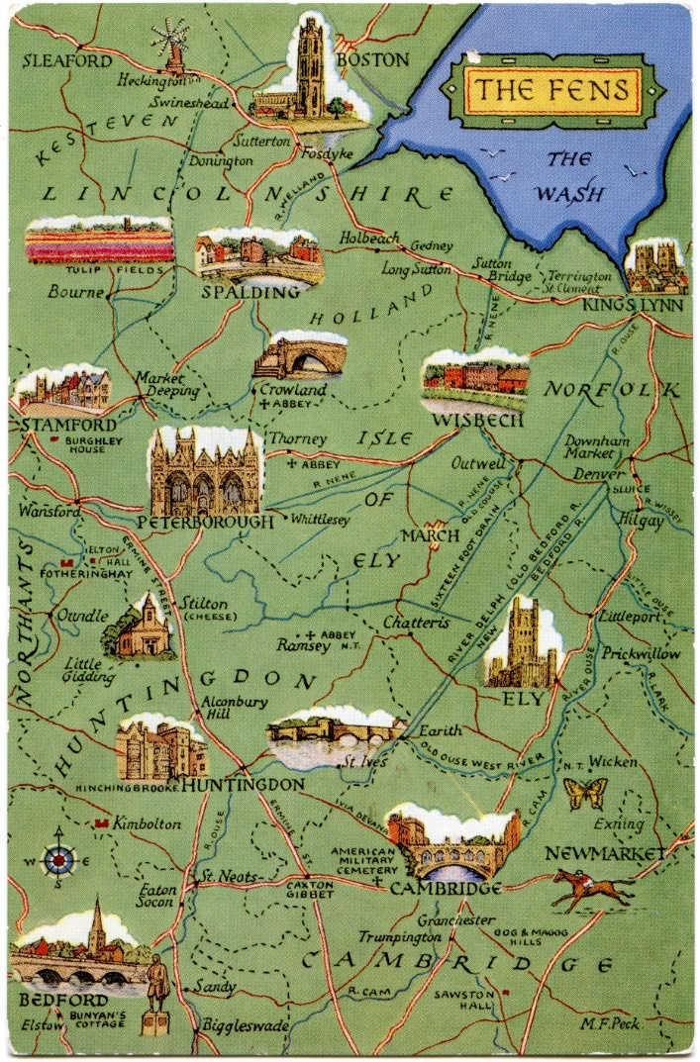
Flat – Normally found in urban, more built up areas.
Terrace – A row of houses all attached, with or without gardens. Often found in towns.
Semi-detached – A house attached to one other, often with a garden.
Detached – A house that stands alone, often with a garden and o other houses attached.

