Meindert Hobbema
Artists
Unit: Symmetry and form
Term: Spring 1
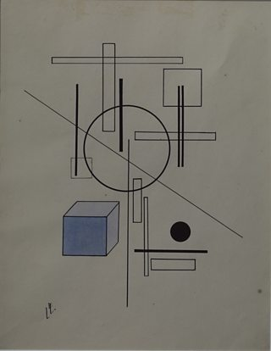
El Lissitzky
Vocabulary:
Symmetrical | Something is symmetrical when it is the same on both sides
Asymmetrical | Having parts that fail to correspond to one another in shape, size, or arrangement; lacking symmetry
3D | A three-dimensional shape is a solid figure or an object or shape that has three dimensions – length, width and height.
Height | The measurement of someone or something from head to foot or from base to top
Width | The measurement or extent of something from side to side; the lesser of two or the least of three dimensions of a body.
Depth | The distance between the nearest end and farthest end of an object

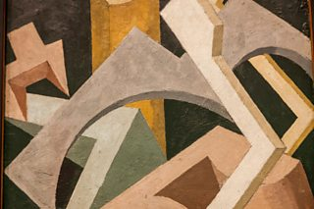
Jessica Dismorr

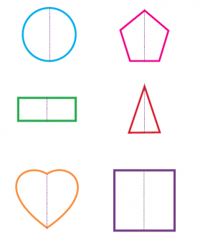
Lines of Symmetry

