Our shadows change in shape and size as the position of the sun changes throughout the day.



**Concave**

When a mirror is bent inwards, creating a hollow – the image looks bigger.

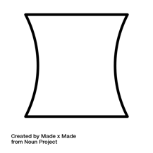

**Convex**

When a mirror is bent outwards, creating an arch– the image looks smaller

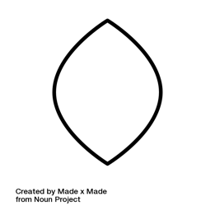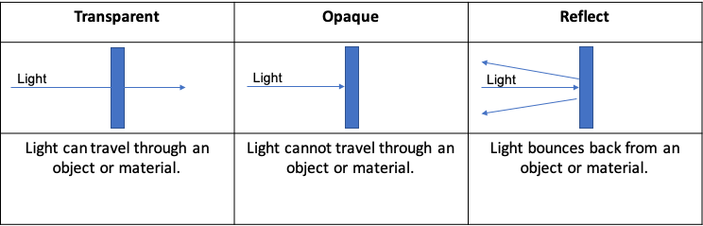

**Unit: Light**

**Term: Spring 1**



|  |  |
| --- | --- |
| **Vocabulary:** | |
| Light | A type of energy that makes it possible for us to see. |
| Dark | The absence of light. |
| Light Source | Where light comes from. |
| Transparent | A property of a material that allows light to travel through it. |
| Opaque | A property of a material that does not allow light through it. |
| Reflect | When light bounces back from a surface. |
| Shadow | A dark area created by an object blocking a light source. |