Vocabulary:
Anglo-Saxon | A mix of people from Germany, Denmark and the Netherlands who came to live in England.
kingdom | A country or place ruled by a king or queen.
Picts | Early settlers in Scotland who fought with the Romans.
Viking | People of Scandinavian origin who travelled by sea and raided, invaded and settled in Europe.
Scots | People who lived in Scotland (previously thought to have migrated from Ireland).
migration | Where people move from one place to live in another place.
settlement | A place where people live, and sometimes work.
raid | An unexpected attack where an enemy comes to steal and/or destroy.
Pagan | A word used to describe people who believe in many gods and goddesses.
Danelaw | The area of northern and eastern England ruled by the Vikings.
Danegeld | Money, or goods, paid by the Anglo-Saxons to the Vikings to stop them invading more places
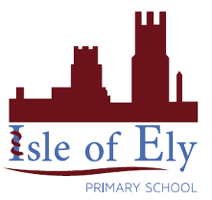
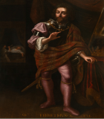
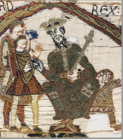
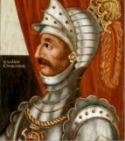
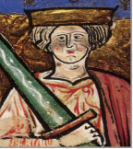
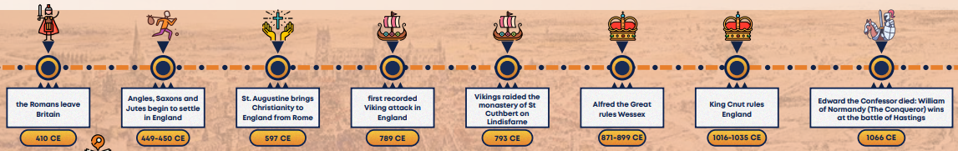
Unit: The Anglo Saxons
Term: Spring 1
Kenneth
MacAlpin
Edward the Confessor
William the
Conqueror
Ethelred the
Unready

