History of London
43 | 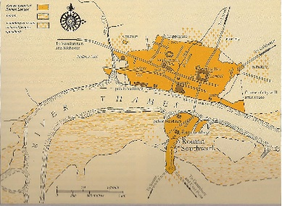  Romans build Londinium on the banks of the Thames river
900 | London became a centre of trade during Viking attacks.
1066 | After the Norman invasion, governmental institutions were moved to London
1300-1600 | 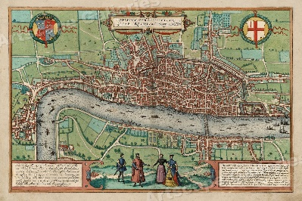  During the 14th, 15th, 16th and 17th Centuries, the city expanded due to its port and textile industry.
1665 | London was cramped inside the old Roman walls leading to the Great Plague (1665) and Great Fire of London (1666).
1675 | London is rebuilt and becomes a social centre with great palaces, theatres and museums. Christopher Wren designs St. Pauls Cathedral
1800 | 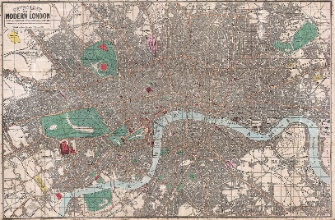  The Industrial revolution led to the overcrowding and the Thames became very polluted.
1945 | During World War 2, large areas of London were destroyed by the Blitz.
1980 onwards | Modern London is a centre for business and finance. Tourists visit the historical buildings, theatres, shops and markets.
Knowledge Organiser
Year 4 – Spring Term A
Geography – London as the Capital
Vocabulary
Population | The number of people living in an area.
The Thames | The river that flows through London.
port | A town or city which boats can sail into.
industry | A way to work to make money.
train line | Track that trains travel on, a fast way to travel.
underground | Trains that run underneath cities.
