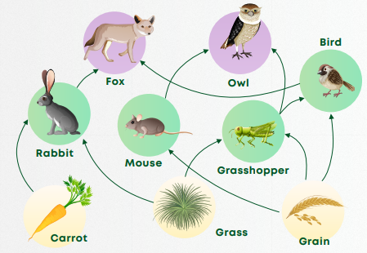
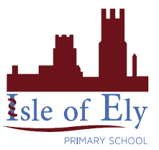
Knowledge Organiser
Year 4 – Spring 1
Science: Ecology
Key Vocabulary | Definition
Habitat | The natural home or environment of an animal, plant, or other organism.
Producer | A living thing, usually a plant, which produces its own food.
Consumer | A living thing, usually an animal, which feeds on plants or other animals.
Decomposer | A living thing, usually a bacterium or fungus, which breaks down the cells of dead plants and animals into simpler substances.
Ecosystem | A system formed by the interaction of organisms with their environment.
Pollution | A system formed by the interaction of organisms with their environment.

- All these organisms share an ecosystem.
- The ecosystem will change if anything new comes into the web or leaves it.
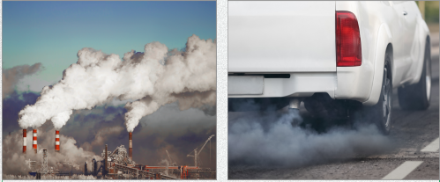
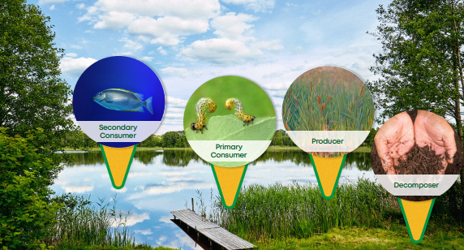
- Air pollution is one way that humans can damage the environment.
- Exhaust from vehicles and smoke from factories can cause air pollution

