How to tie a quilters knot
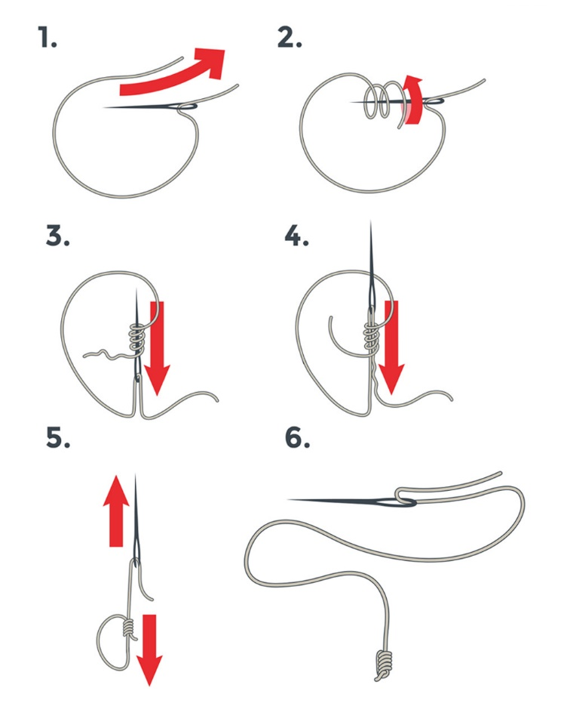
Running Stitch
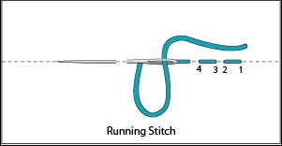
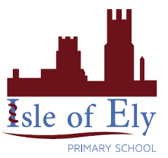
Knowledge Organiser
Year 4 – Summer Term A
Art – Types of Art: Embroidery and Needlework
Vocabulary
needle | A slender piece of metal with a point at one end and a hole at the other.
thread | A length of a thin piece of cotton or wool.
running stitch | A simple stitch used to join two pieces of fabric or to create an outline.
knot | A fastening made in a thread by looping on itself and tightening it.
sampler | A piece of embroidery worked in various stitches as a specimen of skill, typically containing the alphabet and some mottoes.
design | A plan or specification showing dimensions and materials to be used.

Examples of Embroidery and Needlework
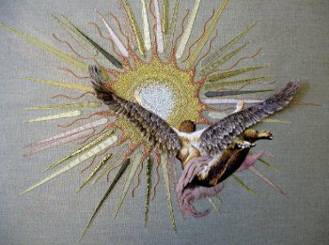 | 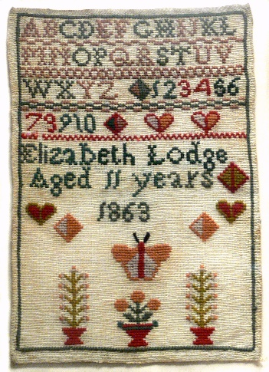 | 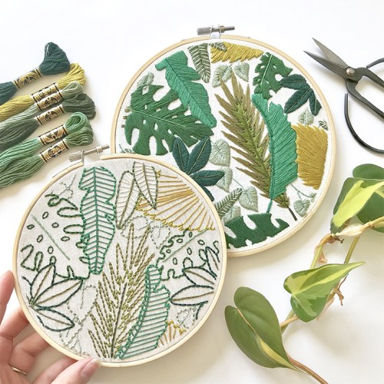
Kate Farrer, Icarus, 2012 | Traditional samplers | Modern embroidery art

