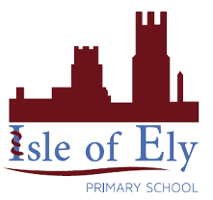
Knowledge Organiser
Year 4 - Autumn Term A
Art - Elements of Art
Vocabulary
Tertiary | Colours made by mixing a primary and a secondary colour.
Shade | A shade can be made by adding black to a colour.
Tint | A tint can be made by adding white to a colour
Tone | A tone is made by adding grey to a colour
Contour Lines | Contour lines are used to outline the shape of an object.
Descriptive Lines | Descriptive lines are used to show texture.

Noon by Vincent Van Gough (1980)
Colour
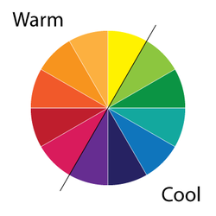
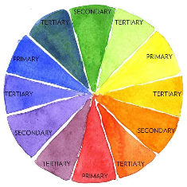

Primary, Secondary and Tertiary Colours / Warm and Cool Colours / Shades, Tints and Tones
Tone can be created by using a technique called stippling. Here are a few examples:
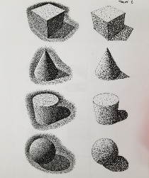
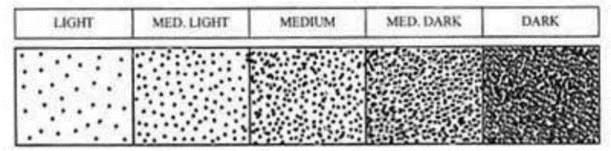

Contour and Descriptive Lines
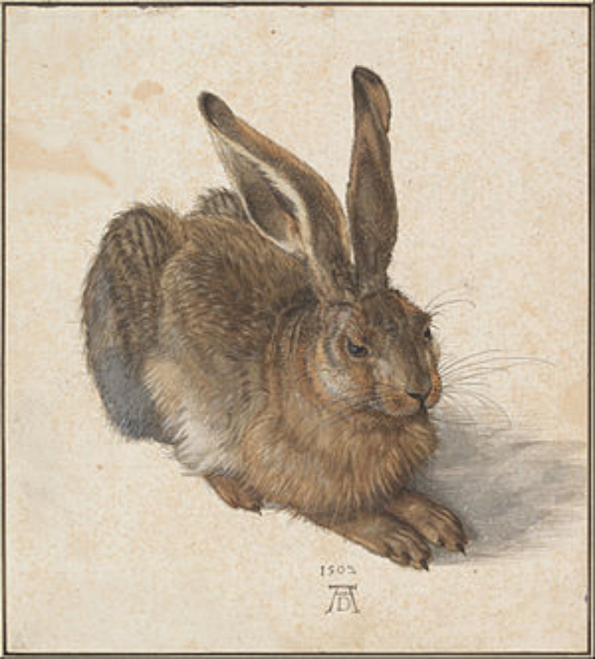
Can you see the difference types of lines in these two pictures?
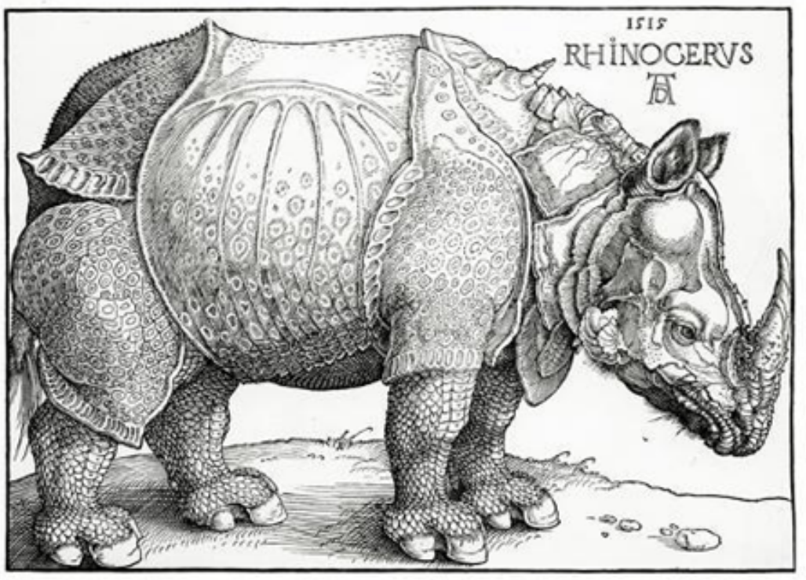

Can you compare these pictures? Thinking about the different use of colour, lines and the texture?
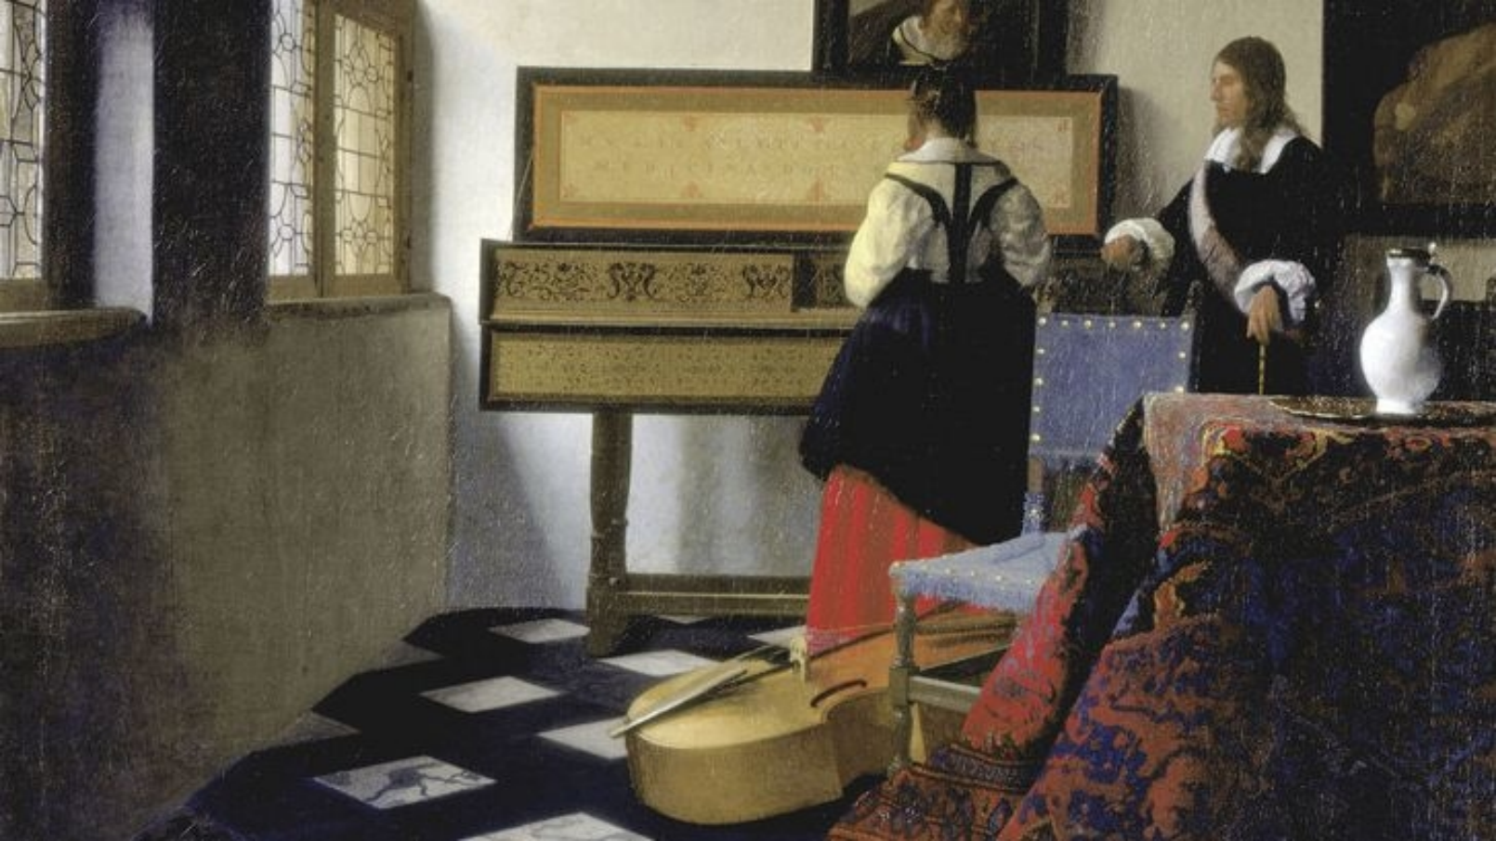
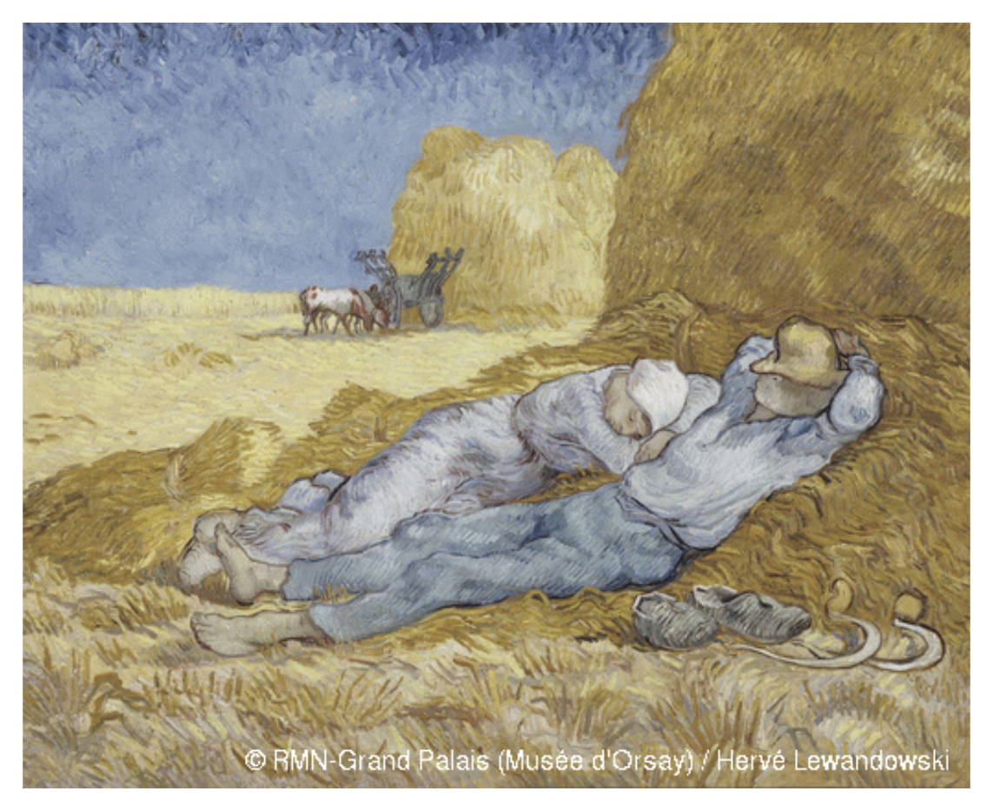
The Music Lesson by Johannes Vermeer (1662)

