Vocabulary
Adapt | To change or improve something to fit a given purpose or to improve it.
Budget | To set an amount of money that can be used for something, and then making sure you don’t spend more than the amount set.
Equipment | Items and objects which are needed to complete a task.
Evaluation | When you look at the good and bad points about something, then think how you could improve it.
Flavour | How food or drink tastes.
Ingredients | Items that make up a mixture, for example foods that make a recipe.
Method | Following a process or list of instructions.
Net | A flat 2D shape, that can become a 3D shape once assembled.
Prototype | A simple model that lets you test out your ideas, showing how it will look and work.
Target audience | A person or particular group of people at whom a product is aimed.
Utilities | Services such as water, electricity, gas and internet.
Knowledge Organiser
Year 4 - Autumn Term A
There are five flavours our tongues can detect.
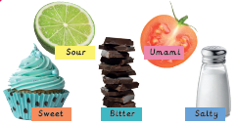
DT – Adapting a recipe
Ingredients that add flavour
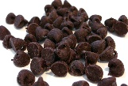 | 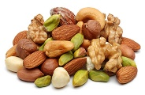 |  | 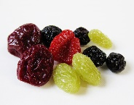
Chocolate | Nuts | Vanilla | Dried fruit

