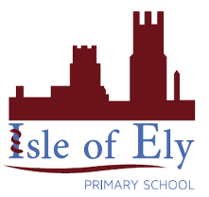
Knowledge Organiser
Year 4 - Autumn Term A
Geography – Spatial Sense: Latitude
Vocabulary
Aerial view | Maps and plans are drawn from above, a birds eye view.
Fens | An area of low marshy ground, that is frequently flooded.
Grid reference | Co-ordinates that help us find locations of a map. They are written in brackets (across, up).
axis | Lines across the side and bottom of a map
atlas | A book of maps.
latitude | The distance north or south of the Equator measured in degrees.
Equator | An imaginary line around the middle of the planet, halfway between the North Pole and South Pole.

Changes in the local area.
The local area used to be flooded fenland. The Isle of Ely is named after the eels. | Water pumps and the Bedford rivers were built to dry the land for farming. | Ely has grown lots recently. The houses around the school are new.
Tropics of Cancer and Capricorn
The Tropic of Cancer is a line around the globe marking the most Northern places the sun can be directly overhead. 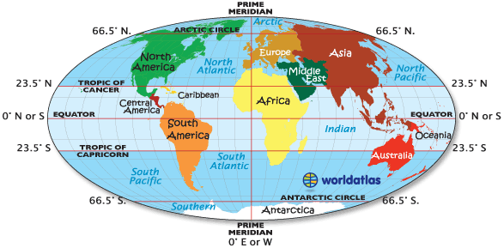
The Tropic of Capricorn is a line around the globe marking the most Southern places the sun can be directly overhead.
How can we find locations?
 | 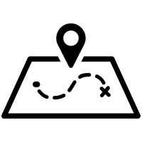
The index of an atlas is arranged in alphabetical order. The index tells us the page number and the grid reference. | A grid reference tells us a specific location on a map. We read it across, then up. | On a digital globe we can search for specific places. The Tropics of Cancer and Capricorn are imaginary lines, not specific places.

