Knowledge Organiser
Year 4 - Autumn Term A
Religious Education – Christianity – Why are churches different?
Vocabulary
Advent | The arrival of a notable person or thing
Church | A building used for public Christian worship
Creation | The action or process of bringing something into existence
Bible | The collection of sacred writings of the Christian religion, comprising the Old and New Testaments.
BC | Before Christ
AD | A.D stands for anno domini, Latin for “in the year of the lord

BC and AD Timeline
There is no biblical authority for BC/AD; it was created over 500 years after the events described in the Christian New Testament (Bible) and was not accepted usage until after another 500 years had passed.

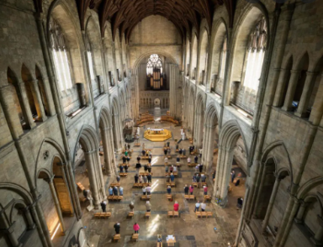
The Churches

There are over 47,000 churches registered in the UK. A lot of their activities centre around worship services, almost always on a Sunday and sometimes during the week
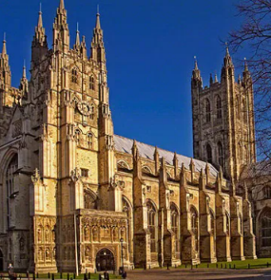
Most church services contain common features – just in different styles and in different orders.

The Christian Calendar
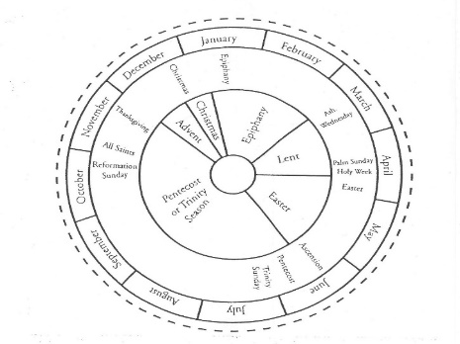
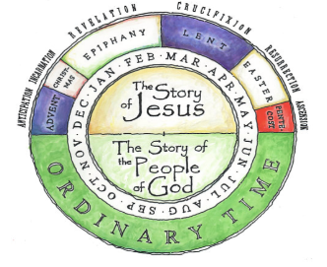

- Each season has its special characteristics, colours and associations.
- Each of these seasons helps Christians focus on particular aspects of God and the plans that he has for his people.
- These seasons are called Advent, Christmas, Epiphany, Lent and Easter.
- The times in between these seasons are known as ‘Ordinary time’.

