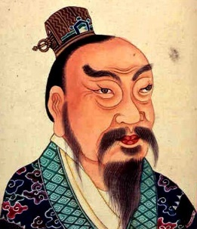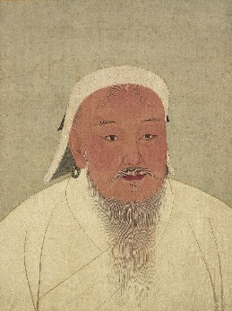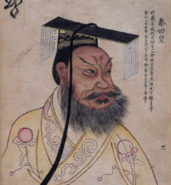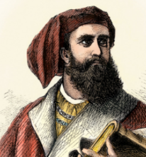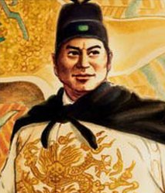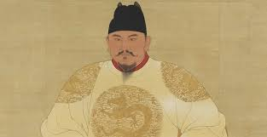

**Key Vocabulary:**

**Emperor-**The ruler of an empire.

**Empire-** A group of states or countries ruled by a single person or group.

**Dynasty-** A line of rulers of a country.

**Government** - A group of people that have the power to rule in a place.

**Conquest** – The process of conquering somewhere.

**Uprising** - The act of rebelling or rising up against leaders.

**Mariner-** Someone who works on a boat or ship.

**Great Wall of China-** A series of forts and walls built along the northern border of China to protect its empire.

**Terracotta Army-** A collection of terracotta sculptures said to protect the emperor in the afterlife.

**Silk Road-** A route connecting parts of Asia with Africa and Europe. Silk was often transported.

**The Forbidden City-** The former imperial palace in China’s capital Beijing.

**Emperors:**

. **Qin Shi Huang** - The first emperor of China.

. **Liu Bang/Han Gaozu**- The first emperor of the Han Dynasty.

. **Li Yuan** – The first emperor of the Tang Dynasty.

. **Zhao Kuangyin** – Ex general and the first emperor of the Song Dynasty.

. **Genghis Kahn** - Founder and first emperor of the Mongol Empire.

. **Kublai Kahn** - Grandson of Genghis Khan, first emperor of the Yuan Dynasty.

. **Zhu Yuanzhang** - The first emperor of the Ming Dynasty.

**Key Figures:**

. **Marco Polo**- Explorer and traveller.

. **Zheng He**- Mariner and Explorer of the Indian Ocean.

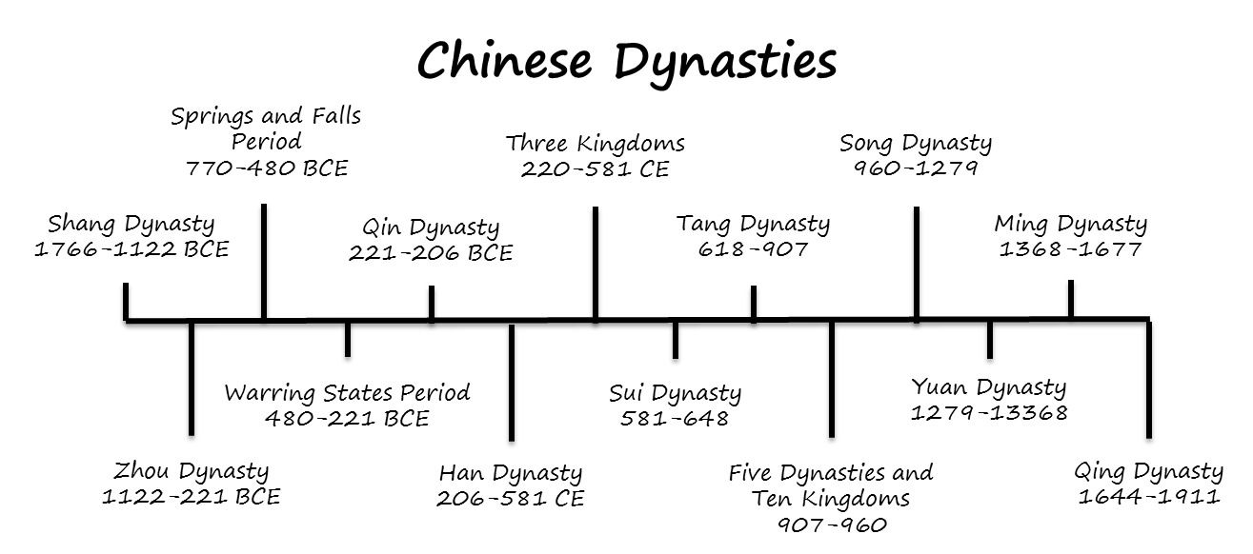

**History Knowledge Organiser**

**China: Dynasties and Conquerors**

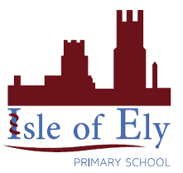

Key figures: