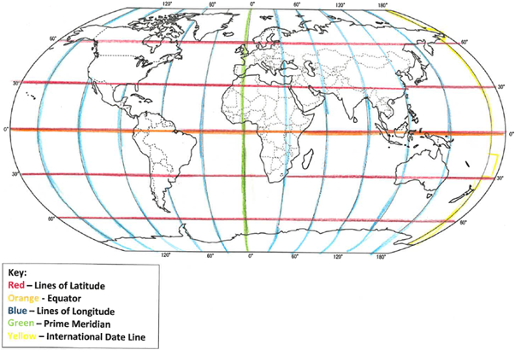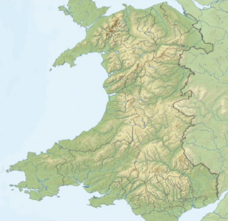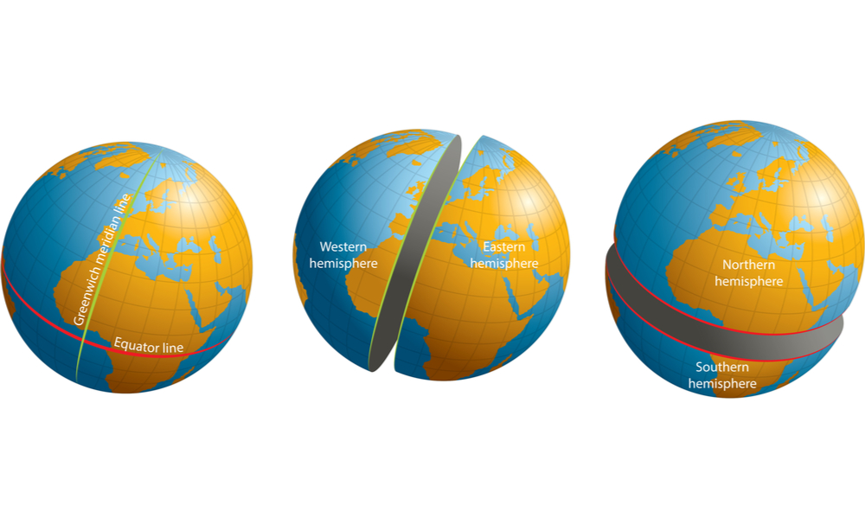

**Key Vocabulary:**

**Scale** – The relationship between distance on a map and in the real world.

**Scale Factor** – The number used to multiply one object by to get another object that looks the same but is a different size.

**Contour** – Lines drawn on a map to show changes in levels.

**Latitude** – Lines running from an East-West direction across the Earth.

**Longitude** – Lines running from a North-South direction down the Earth.

**Meridian** – A line of Longitude that goes from the North Pole to the South Pole.

**Hemisphere** – Half a sphere, or one half of the Earth. These are described as the North and South hemispheres.

**Key Facts:**

. Cartographers use imaginary lines to help them locate places on maps.

. The **Equator** divides the Northern and Southern hemisphere.

. The **Prime Meridian** divides the Eastern and Western hemispheres.

. A co-ordinate is a point where lines on a globe cross over.

. Map scale help to measure the distance between places on a map.

. **Relief maps** show the height of land. For smaller areas, contours can be used to show the land height changing.

**Geography Knowledge Organiser**

**Co-Ordinates and Scaling**



Key figures: