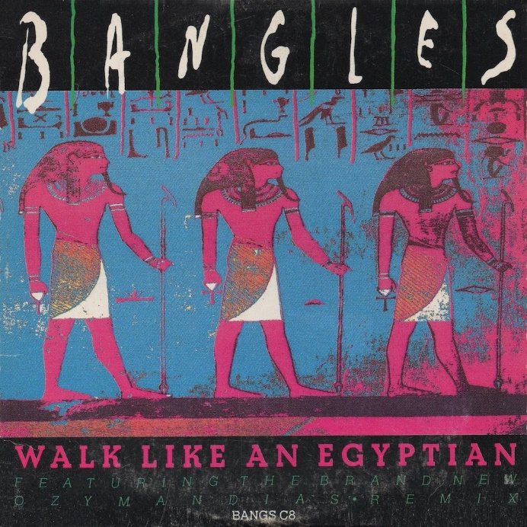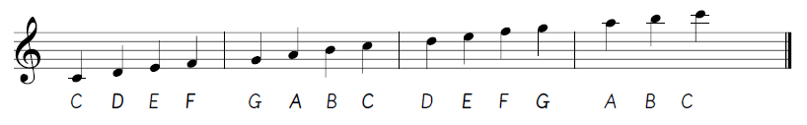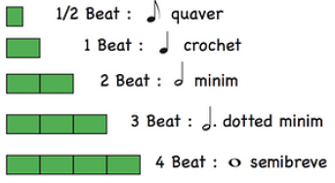

**Ensemble**

**Minor key**

**Compose**

**Notation**

**Tempo**

**Repetition**

**Letter Notation**

**Note Lengths**

**Unison**

**Repeating**

**Melody**

**Structure**

**Composition**

**Features**

**Key Vocabulary:**

**Music Knowledge Organiser**

**Composing Notation (Egyptians)**



Key figures: