**Art Knowledge Organiser**

**Elements of Art**

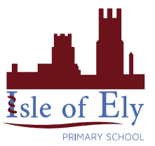

**Key Vocabulary:**

**Harmonious Colours** – colours that sit next to each other on the colour wheel.

**Complementary Colours** – colours that are across from each other on the colour wheel.

**Expressive Lines** – They are different types of lines that can be used to express mood and emotions in artwork.

**Actual or Tactile Texture** – is what something feels like when you touch it.

**Visual Texture** – is how you think something feels by the way it looks.

**Organic Shapes –** they are imperfect and irregular and can be found in nature.

**Geometric Shapes** – they are mathematical shapes which are regular and perfect.

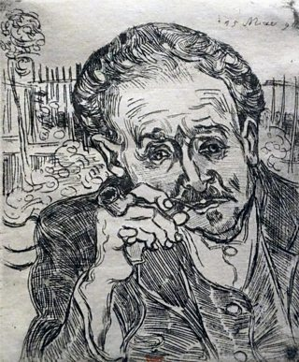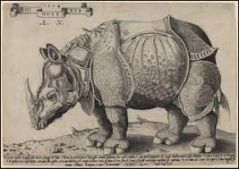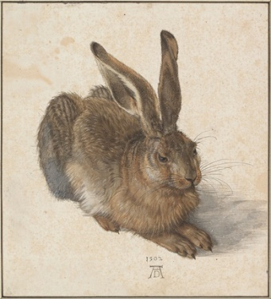

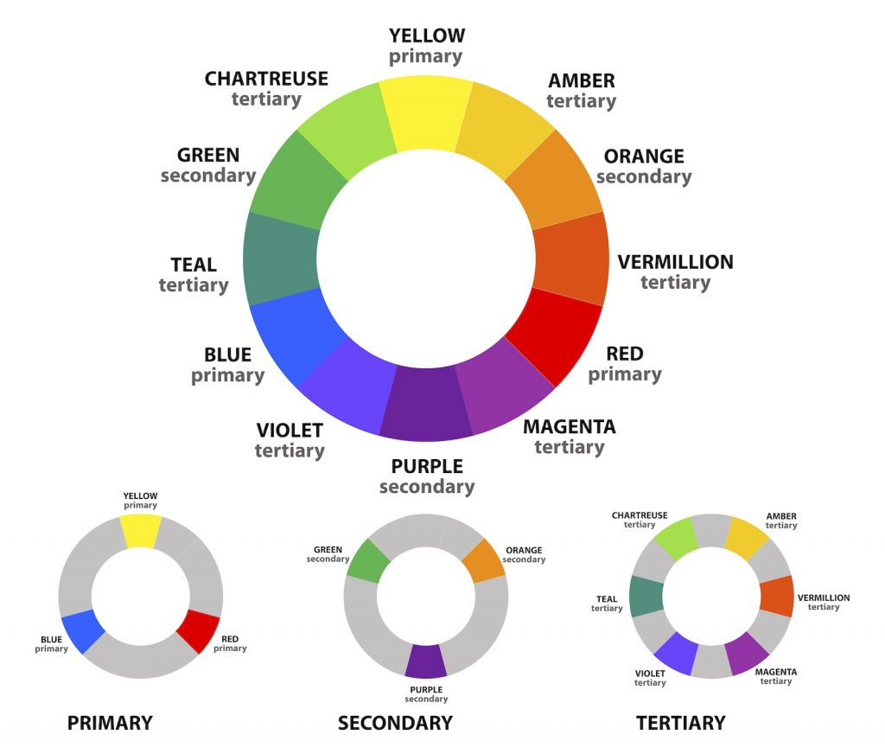

**Colour Wheel**

**Key Facts:**

. Red, yellow, and blue are primary colours and you can create any other colour from the three primary colours.

. Secondary colours are made when mixing two primary colours together.

. Tertiary colours are made when you mix a primary colour and a secondary colour.

. A contour line is a line that defines a form or edge. Essentially, it is the outline of an object or figure.

. Paisley pattern is built up of repeating organic shapes.

Key figures: